***Generic Version: Just add your favorite article, pictures, videos and change highlighted text to indicate your subject.***

|  |  |  |  |
| --- | --- | --- | --- |
| **Teacher Version** | | | |
| **Grade** | **1** | **Title/Subject** | **Type your subject here** |

The following sections are included in this Teacher Version:

• **Overview** • **Process: Day 1 and 2** • **Teacher Directions for Scoring Rubric**

|  |
| --- |
| **Overview** |

On Day 1 students will engage in a video viewing, shared reading and note-taking activity to learn about the subject. After the group activity, they will be directed to plan, and begin to draft an informative writing piece about the subject utilizing the information they read in the texts as well as notes they took during the shared lesson. On Day 2 students will finish their drafts, revise and edit their writing, and if they choose, produce a final copy.

|  |
| --- |
| **Process** |

**DAY 1: Video Viewing, Shared Reading and Note-taking:** Up to 60 minutes

**Step 1: Connect to Background Knowledge** ~ 15 minutes

Provide an introduction to the classroom activity by indicating that after this activity, students will be writing an essay focused on the subject. Ask students to share orally what they might know about the subject. Possible questions could include:

*“Have you ever seen ____________? What do _________ look like? What do _____ sound like? Where do ____ live? How do _____ protect themselves? What else do you know about ____?”*

For active engagement encourage pair or group sharing, before sharing out with whole group.

Have the class watch one or more of the following video clips on the subject.



***Put link to video/s here.***

**Step 2: Accessing the Information**

1. Explain: *“Now we will read two sources.”* Read both sources, pointing out important facts and features (pictures, captions, etc.) Use ONLY the sources provided in this prompt packet.
2. Lead a whole class discussion about the sources, during which students generate a key word list, list the “gist” next to each paragraph, highlight important words/phrases, or participate in pictorial narrative input (large teacher-created drawing with labels).
3. Think-Pair-Share: *“Tell your partner what you learned.”* Make sure both partners have time to share with each other.

**Step 3: Clarify Expectations for the Writing Task:**

**Explain**: *“Now you will have a chance to look at the sources, plan, and write a draft to explain to me what you learned about. Tomorrow you will have a chance to write more, and edit your work from today to finish your piece.”*

Review the student directions and checklist for the writing assignment and give each student a sheet of blank paper for planning and lined paper for writing.

**Step 4: Writing**

Tell students to begin planning their writing on the blank sheet of paper. You can remind them of planning strategies you have taught in your classroom such as outlining, lists, webs, or drawing. Don’t provide a plan yourself, just remind them of the strategies for planning.

After 10 minutes suggest to students that they begin writing their drafts.

Collect all materials from Day 1 after the 60 minutes total is complete.

**DAY 2: Revising and Editing** Up to 45 minutes

1. Allow students to access the sources, their notes, the classroom activity charts/key word lists, and their draft.
2. Students read the prompt and their draft from Day 1 to add more information or make revisions.
3. Students edit their writing on their own, you may prompt them to do this by reviewing the student directions.
4. At teacher discretion, students may use word processing for draft or revision as long as spelling and grammar correction tools have been disabled.
5. Inform students when 5 minutes remain.
6. Collect all student writing materials.

|  |
| --- |
| **Teacher Directions for Scoring Rubric:** |

Student responses to Part 2 will be scored using the Common Core based Informative/Explanatory Writing Rubric. A score will be given in each of the three rubric categories. For grade 1, student **revisions** will be scored.

Each student’s final scores should indicate a 1, 2, 3, or 4 in each of the three categories (no partial scores such as 2.5, 3+, etc.). A score of 3 or 4 in each category is considered a passing score and a total of 8 points or higher out of 12 total is considered a passing overall score.

The score for each of the three categories will be entered for each student into the assessment log.

|  |  |  |
| --- | --- | --- |
| **Grade** | **1** | **Informative/Explanatory Writing Rubric** |

|  |  |  |  |
| --- | --- | --- | --- |
| **Level** | **INFORMATIVE/EXPLANATORY WRITING** | **LANGUAGE CONVENTIONS** | **WITH GUIDANCE and SUPPORT**  **FROM ADULTS** |
| 4  **Exceeds** | * Meets all expectations in level 3 * Uses many descriptive words * Writes many complete sentences * Includes many facts and details | **Mostly correct** use of language conventions, and some above grade level skills used, for example:   * Meets all expectations in level 3 * Consistently spells grade level appropriate words correctly * Capitalizes holidays, product names, and geographic names * Uses an apostrophe to form contractions and possessives | Level of guidance and support from adults before writing:  Check off what was done before the student wrote the piece being scored.   * Discussion * Read aloud or shared reading * Drawing * Vocabulary word bank * Shared or interactive writing * Graphic organizer * Language frames |
| 3  **Meets** | **INFORMATIVE/EXPLANATORY WRITING** (W2)   * Writes an informative piece about a topic * Names the topic * Provides some facts about the topic * Provides some sense of closure   **WRITING PROCESS** (W5-W8)   * **WGASFA** * Adds details to strengthen writing as needed (W5) * **WGASFA** * Uses a variety of digital tools to write and publish writing (W6) * **WGASFA** * Recalls information from experiences or gathers information from provided sources to answer a question (W8) | **Adequate** use of correct sentence formation, punctuation, capitalization, grammar usage and spelling for grade level, for example:   * Prints all upper- and lowercase letters (L1a) * Produces and expands complete simple and compound declarative, interrogative, imperative, and exclamatory sentences in response to prompts (L1j) * Capitalizes dates and names of people (L2a) * Uses end punctuation for sentences (L2b) * Uses commas in dates and to separate single words in a series (L2c) * Uses conventional spelling for words with common spelling patterns and for frequently occurring irregular words (L2d) * Spells untaught words phonetically (L2e) |
| 2  **Almost Meets** | * Names topic and supplies at least one fact * Does not include closure or closure is unclear * **WGASFA** * Adds few facts or details * **WGASFA** * Recalls little information from sources | **Limited** use of correct sentence formation, punctuation, capitalization, grammar usage and spelling for grade level, for example:   * Writes most uppercase and lowercase letters correctly * Writes mostly simple sentences, and may rely on patterned sentences to write * Uses some end punctuation marks correctly * Spells some words phonetically |
| 1  **Does Not Meet** | * Makes few or no attempts to write * Does not name topic * Provides no facts | **Infrequent** use of correct sentence formation, punctuation, capitalization, grammar usage and spelling for grade level, for example:   * Makes no or few attempts at correct spelling * Has many errors in capitalization * Writes no or few complete sentences * Makes no or few attempts at end punctuation |

* **WGASFA**: “with guidance and support from adults”

This rubric was adapted from rubrics at sbusd.org and information from Smarter Balanced Assessments (www.**smarterbalanced**.org) using the California Common Core Standards at www.cde.**ca**.gov.

***If you want, add pictures here.***

***The remaining pages are for the student version***

***for copying for each student.***

|  |  |  |  |
| --- | --- | --- | --- |
| **Student Version** | | | |
| **Grade** | **1** | **Title/Subject** | **Type your subject here** |

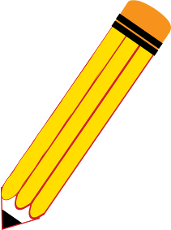

As you think about what we just read, write to explain to me what you learned about.



Good work!

* Be sure to write a **title**
* Write a **topic sentence**.
* Also, write about at least 4 things that you learned.
* End with a **conclusion**.
* You can look at the sources and our key word list to help you with your writing.

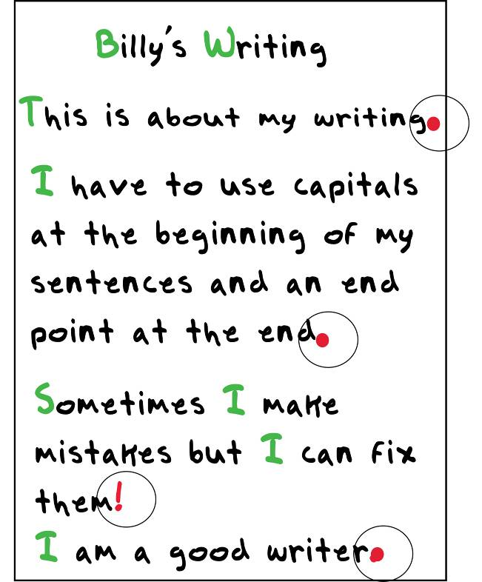

* You may want to draw a picture on the planning page to help you with your thinking.
* Do not copy sentences from the sources.
* Does your writing make sense?
* Have you used science words from the text?
* Is there missing information you want to add?

***Be sure to…***

* + Use **capitals** at the beginning of sentences
  + **Capitals** for proper nouns
  + Use **end points** at the end of your sentences **. ! ?**
  + Check your spelling
  + Try to use complete sentences
* Fix your mistakes.
* Make sure to leave spaces between your words.
* Use your neatest handwriting.

|  |  |  |  |
| --- | --- | --- | --- |
| **Student Reading Text** | | | |
| **Grade** | **1** | **Title/Subject** | **Type your subject here** |

***Add articles here…at least 2.***

|  |  |  |  |
| --- | --- | --- | --- |
| **Student Reading Text** | | | |
| **Grade** | **1** | **Title/Subject** | **Type your subject here** |

|  |  |  |  |
| --- | --- | --- | --- |
| **Student Reading Text** | | | |
| **Grade** | **1** | **Title/Subject** | **Type your subject here** |