***Generic Version: Just add your favorite article, pictures, videos and change highlighted text to indicate your subject.***

|  |  |  |  |
| --- | --- | --- | --- |
| **Teacher Version** | | | |
| **Grade** | **7-8** | **Title/Subject** | **Type your subject here** |

The following sections are included in this Teacher Version:

• **Overview**

• **Process: Day 1, 2 and 3**

• **Teacher Directions for Scoring Rubric**

|  |
| --- |
| **Overview** |

On Day 1 students will engage in a shared reading and note-taking activity using two informative texts and an optional video to learn about the topic. On Day 2, after the group activity, they will be directed to plan, and begin to draft an informative/explanatory writing piece about the subject utilizing the information they read in the texts, viewed in the video, along with the notes they took during the shared lesson. On Day 3 students will finish their drafts, revise and edit their writing, and if they choose, produce a final copy.

|  |
| --- |
| **Process** |

**DAY 1: Shared Reading and Note-taking:** Up to 60 minutes

**Step 1: Connect to Background Knowledge**

Provide an introduction to the classroom activity by indicating that after this activity, students will be writing an informative/explanatory writing piece about the topic. Ask students to discuss this orally. Possible questions could include:

*“What do you know about ______? How serious is this ______? What is _____ doing to manage the ______now? What is _____ doing about future prevention measures and methods? What can we citizens do to help the situation now and in the future?”*

For active engagement encourage pair or group sharing, before sharing out with whole group.

**Step 2: Viewing a video and Accessing the Text**

1. Explain: *“Now we will watch a video and read about the topic. There are two articles available. You will be writing an informative paper to your teacher about the drought, picking a particular aspect of the topic including information from the articles and video provided in your paper.”* Read the articles with the students and point out facts, details, and features (pictures, captions, etc.) Use ONLY the sources provided in this prompt packet.
2. Show the video clip: [type](http://www.ask.com/youtube?qsrc=1&o=102593&l=dir&q=california+drought) in link to video here
3. Read the articles with the students as a shared reading. Encourage students to take margin notes as they read.
4. Lead a whole class discussion about the sources.
5. Think-Pair-Share: *“Tell your partner what you learned about the topic.”* Make sure both partners have time to share with each other.
6. Tell students they will now have the rest of the class period to take notes about what they have learned. Display the following writing prompt to help them organize their thinking and choose which evidence they want to capture for their essays:

How do we know _____? What are some of the effects of the _____? What are some ways people can help?

**DAY 2: Planning and Writing a Draft:** Up to 60 minutes

**Step 3: Clarify Expectations for the Writing Task:**

**Explain**: *“In a few minutes you will have a chance to look at the sources, plan, and write a draft to demonstrate what you have learned about the topic Tomorrow you will have a chance to change and edit your work from today or add more detail.”*

Review the student directions and checklist for the writing assignment and give each student a sheet of blank paper for planning and lined paper for writing.

**Step 4: Clarify Expectations for the Writing Task:**

Tell students to begin planning their writing on the blank sheet of paper. You can remind them of planning strategies you have taught in your classroom such as outlining, lists, or webs. Don’t provide a plan yourself just remind them of the strategies for planning.

After 15 minutes, suggest to students that they begin writing their drafts.

Collect all materials from Day 2.

**DAY 3:** Up to 60 minutes

1. Allow students to access the sources, their notes, the classroom activity charts/key word lists, and their draft.
2. Direct students to re-read their draft from Day 2. Review the task using the student checklist poster.
3. When students are done writing, remind them to reread and edit.
4. Students may create a final draft or use word processing to publish their writing if time allows.
5. Collect all student writing materials.

|  |
| --- |
| **Teacher Directions for Scoring Rubric:** |

Use the informative/explanatory writing rubric to score the writing and enter a score for each student into assessment log.

|  |  |  |
| --- | --- | --- |
| **Grade** | **7-8** | **Informative Writing Rubric** |

|  |  |  |  |
| --- | --- | --- | --- |
| **Level** | **INFORMATIVE/EXPLANATORY WRITING** | **LANGUAGE CONVENTIONS** | **WITH GUIDANCE and SUPPORT**  **FROM ADULTS** |
| 4  **Exceeds** | * Meets all expectations in level 3 * Uses well chosen, relevant, and sufficient facts * Maintains a formal style and objective tone in argument * Document is very well presented and documented with excellent organization | **Mostly correct** use of language conventions, and some above grade level skills used, for example:   * Meets all expectations in level 3 * Uses verbs in active/passive voice and in conditional/subjunctive mood to achieve particular effects | Level of guidance and support from adults before writing:  Check off what was done before the student wrote the piece being scored.   * Discussion * Read aloud or shared reading * Drawing * Vocabulary word bank * Shared or interactive writing * Graphic organizer * Language frames |
| 3  **Meets** | **INFORMATIVE/EXPLANATORY WRITING** (W2)   * Introduces topic or thesis statement clearly, previewing what is to follow (W2a) * Organizes ideas, concepts, and information using strategies such as definition, classification, compare/contrast, cause and effect (W2a) * Includes formatting (headings), graphics (charts/tables), and multimedia when aid comprehension (W2a) * Develops topic with relevant facts, definitions, concrete details, quotations, and other information/examples (W2b) * Uses appropriate transitions to create cohesion and clarify relationships among ideas/concepts (W2c) * Uses precise language and domain-specific vocabulary to inform/explain about topic (W2d) * Establishes and maintains a formal style (W2e) * Provides a concluding statement or section that follows from and supports the information or explanation presented (W2e)   **WRITING PROCESS** (W4-W8)   * Writes clearly and coherently and organization and style are appropriate to task, purpose and audience (W4) * **WGASFA\*** Develops and strengthens writing as needed, by planning, revising, editing, rewriting, or trying a new approach, focusing on how well purpose and audience have been addressed (W5) * Uses technology to produce writing and link to and cite sources (W6) * Assesses credibility of each source and quotes/paraphrases the data/conclusions of each source (W8) * Avoids plagiarism and follows a standard format for citation (W8) | **Adequate** use of correct sentence formation, punctuation, capitalization, grammar usage and spelling for grade level, for example:   * Chooses among simple, compound, complex, and compound-complex sentences to signal differing relationships between ideas (L3b) * Places phrases and clauses within a sentence, recognizing and correcting misplaced or dangling modifiers (L1b) * Uses a comma to separate coordinate adjectives (L2a) * Spells correctly (L2b) * Chooses language that expresses ideas precisely and concisely (L3a) * Eliminates wordiness and redundancy (L3a) |
| 2  **Almost Meets** | * Introduction to topic or thesis statement is present but not clear * Has some facts and details but may not be logical or relevant * Does not establish or maintain a formal style * Concluding statement may be unclear or not well supported * Writing may not fully address audience, task, or purpose * Language may not be precise or domain-specific | **Limited** use of correct sentence formation, punctuation, capitalization, grammar usage and spelling for grade level, for example:   * Contains some run-on sentences * Uses mostly simple or compound sentences * Language may not always be precise or appropriate * Contains some punctuation errors * Contains some capitalization and/or spelling errors |
| 1  **Does Not Meet** | * Has very limited information on topic * Has no formal style * Includes little to no facts or focus * Information is disorganized or missing | **Infrequent** use of correct sentence formation, punctuation, capitalization, grammar usage and spelling for grade level, for example:   * Contains many run-on sentences * Contains many punctuation errors * Contains many capitalization and/or spelling errors |

* **WGASFA**: “with guidance and support from adults”

This rubric was adapted from rubrics at sbusd.org and information from Smarter Balanced Assessments (www.**smarterbalanced**.org) using the California Common Core Standards at www.cde.**ca**.gov.



***If you want, add pictures here.***

***The remaining pages are for the student version***

***for copying for each student.***

|  |  |  |  |
| --- | --- | --- | --- |
| **Student Version** | | | |
| **Grade** | **7-8** | **Title/Subject** | **Type your subject here** |

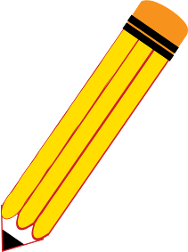

**Student Prompt:**

How do we know ____? What are some of the effects of _______? What are some ways the people can help out?

Write a multi-paragraph essay to respond to one, two or all three of the questions. Include information from the articles as you write.

**Writing Tips:**

* Be sure to introduce the topic and group related facts together.
* Use evidence from the two sources to develop your argument.
* Include linking words and phrases to connect your ideas.
* Maintain a formal style throughout.
* End with a conclusion.

**Reminders:**

* You can look at the two sources and your key word list to help you with your writing.
* Begin by making a plan or drawing a graphic organizer to help you with organizing your thinking.
* Do not copy sentences from the sources.

**Step 1: Plan**

Plan: review the texts and your notes

* Make a plan on the blank paper for your writing.

**Step 2: Draft**

* Introduce your subject and what you want to explain.
* Include evidence to support your explanation.
* Group information together as you write into paragraphs.
* Write a concluding paragraph.
* Write a bibliography of sources for your paper

|  |  |  |  |
| --- | --- | --- | --- |
| **Student Version** | | | |
| **Grade** | **7-8** | **Title/Subject** | **Type your subject here** |

**Step 3: Reread and Revise**

* Does it make sense?
* Have you used evidence from the texts to support your writing?
* Have you used linking words to organize your writing?

**Step 4: Edit**

Reread your writing and revise:

* + Capitals at the beginning of sentences
  + Capitals for proper nouns
  + Punctuation: (end points) **. ! ?**
  + Commas **,** quotation marks **“ ”**
  + Spelling
  + Complete Sentences

**Step 5: Final Draft**

* Recopy or type and fix your mistakes.



Good work!

**Informative Writing Poster**

🗹

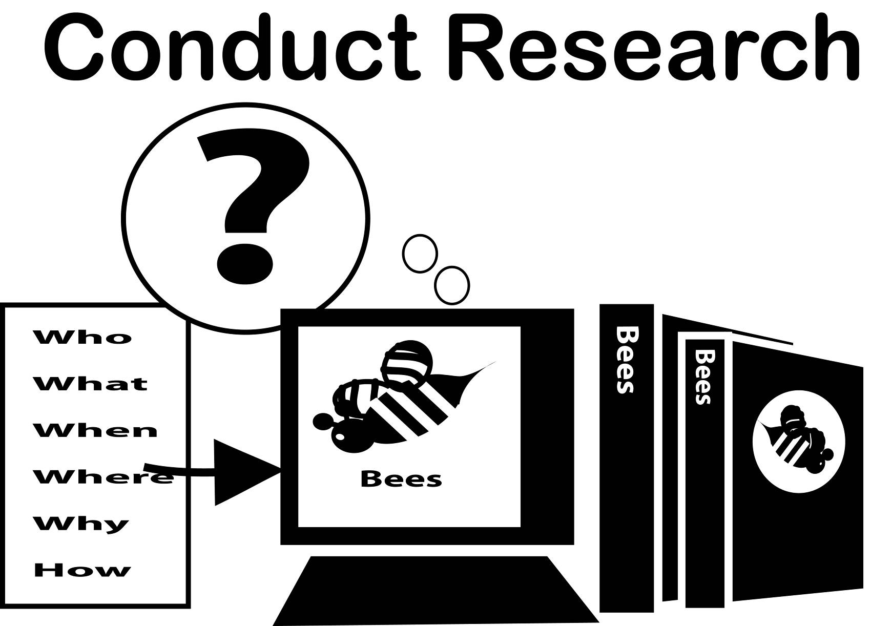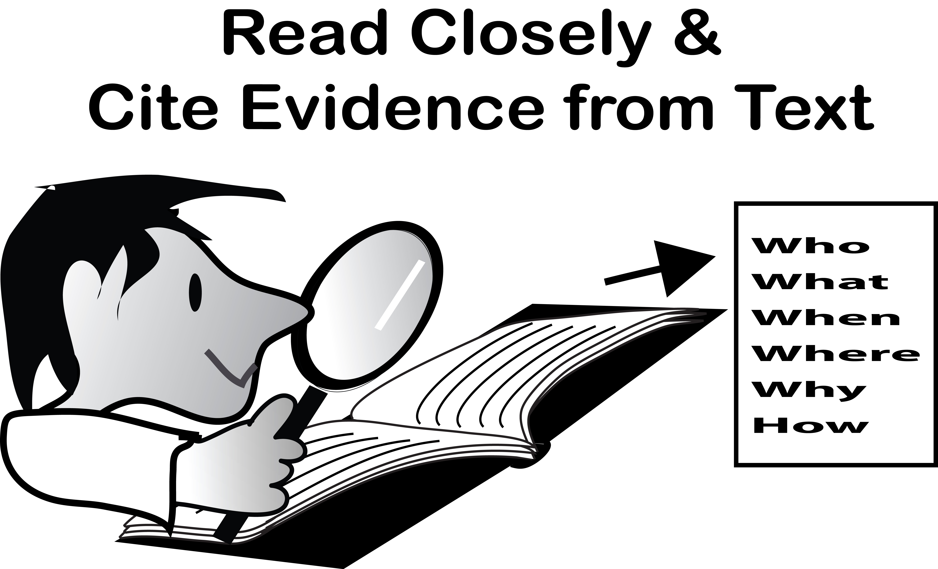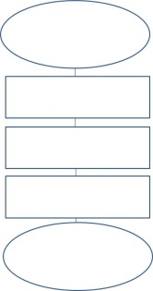

1. *Learn about a topic through research.*
2. *Take notes about what you learned on a graphic organizer or in the margins of the text.*
3. *Choose you’re the information you want to include which goes with your explanation.*
4. *Plan your essay with an outline.*
5. *Write paragraphs to go with each section.*
6. *Use linking words to connect your ideas:*
7. *Write a conclusion to remind the reader of the explanation you wrote about.*
8. *Reread and revise: Does it make sense? Is there any missing information?*
9. *Reread and edit: Check*
   * + *capitals*
     + *spelling*
     + *punctuation*
10. *Type or write a final draft!*
11. *Be proud of your hard work!*



|  |  |  |  |
| --- | --- | --- | --- |
| **Student Reading Text** | | | |
| **Grade** | **7-8** | **Title/Subject** | **Type your subject here** |

***Add articles here…at least 2.***