Grade 7 Constructed Response Questions (2017)

Teacher Version

The practice items were selected from two sources: the practice performance task classroom activity questions, and the SBAC practice test items.  Both sources can provide additional practice for students with writing responses and comparing their answers to the exemplars supplied by SBAC.

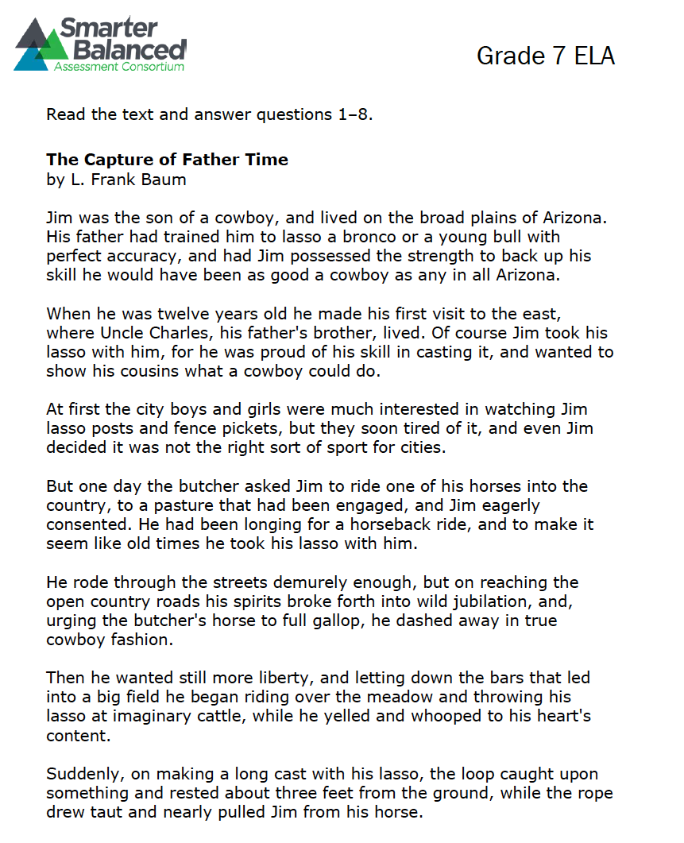

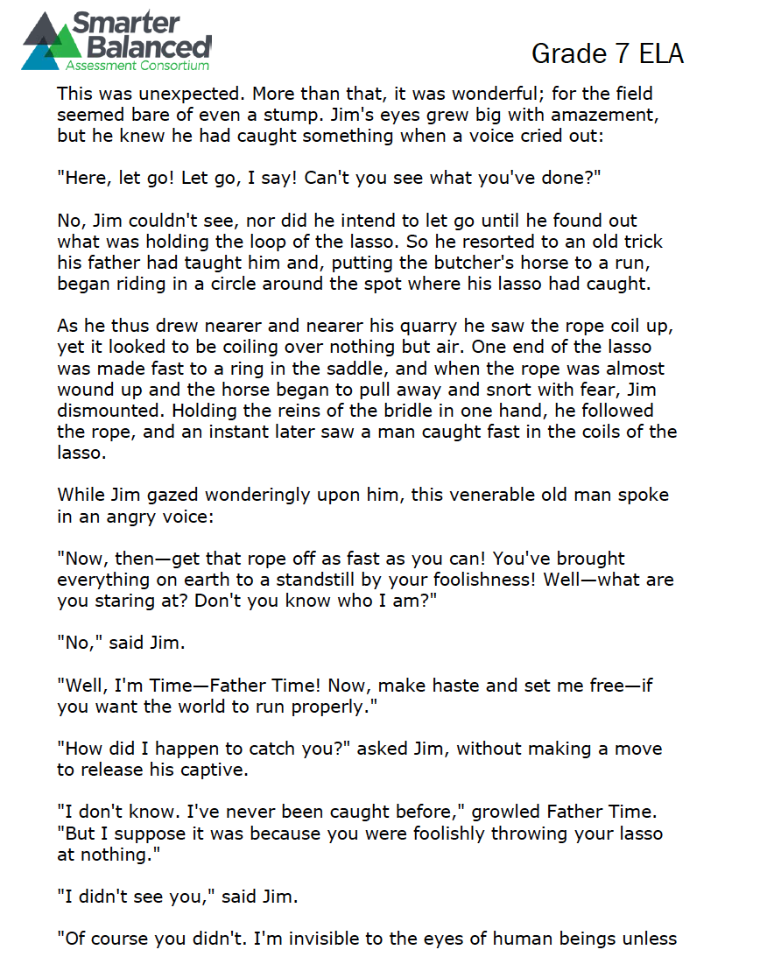

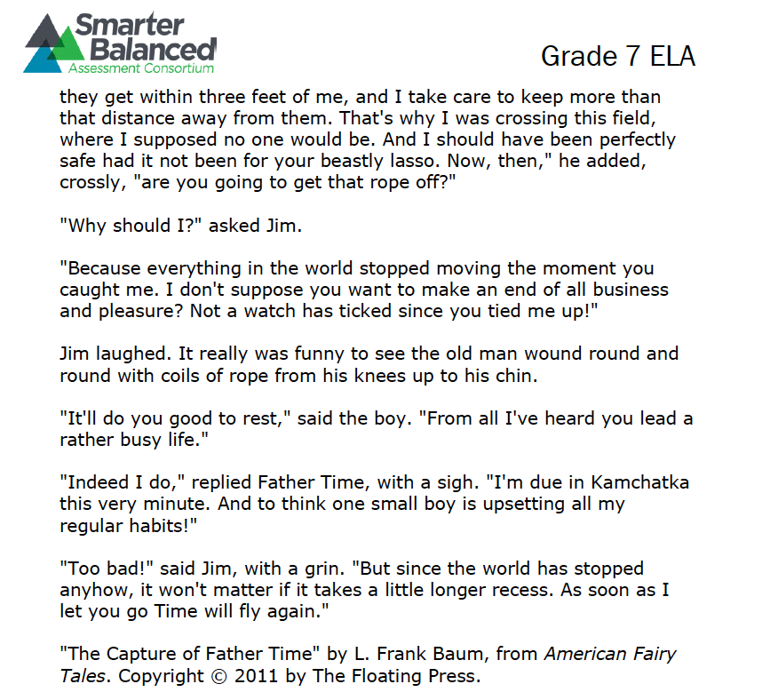

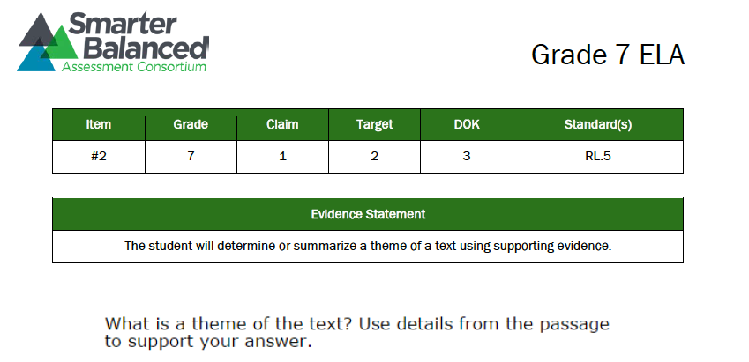

**Type your answer in this box.**

|  |
| --- |
|  |

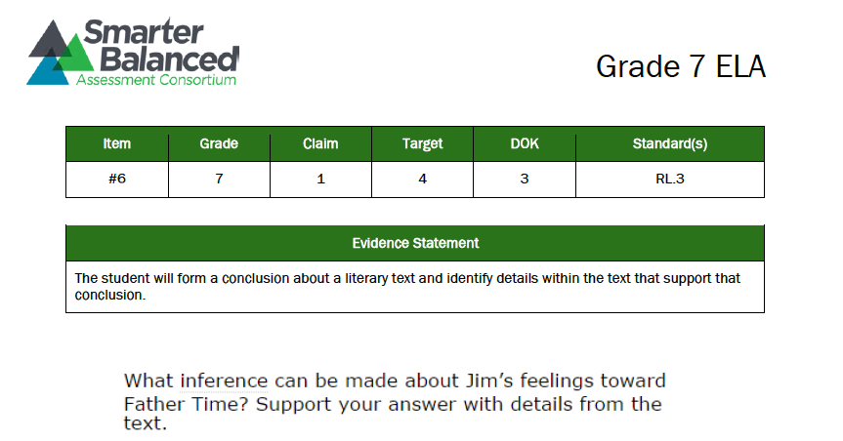

**Type your answer in this box.**

|  |
| --- |
|  |

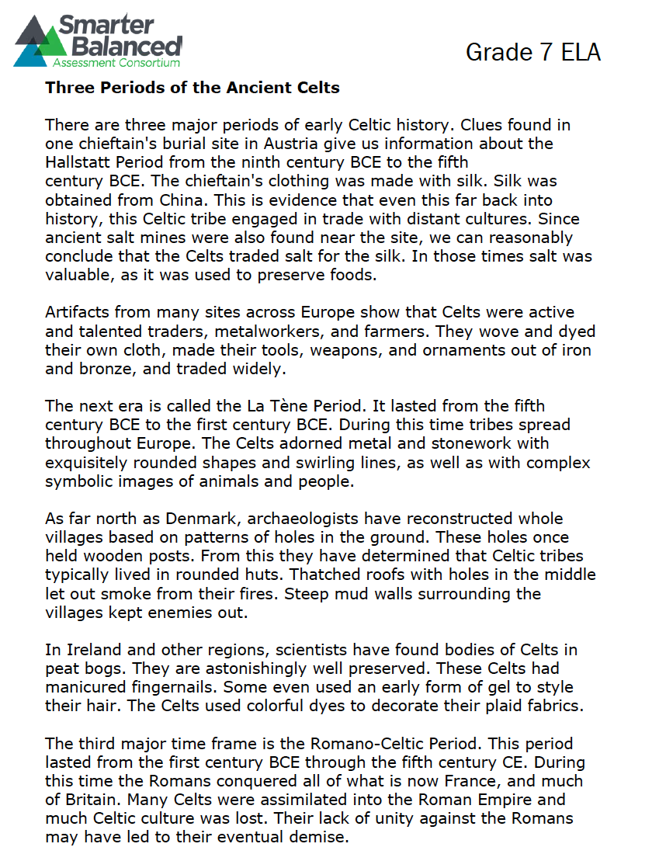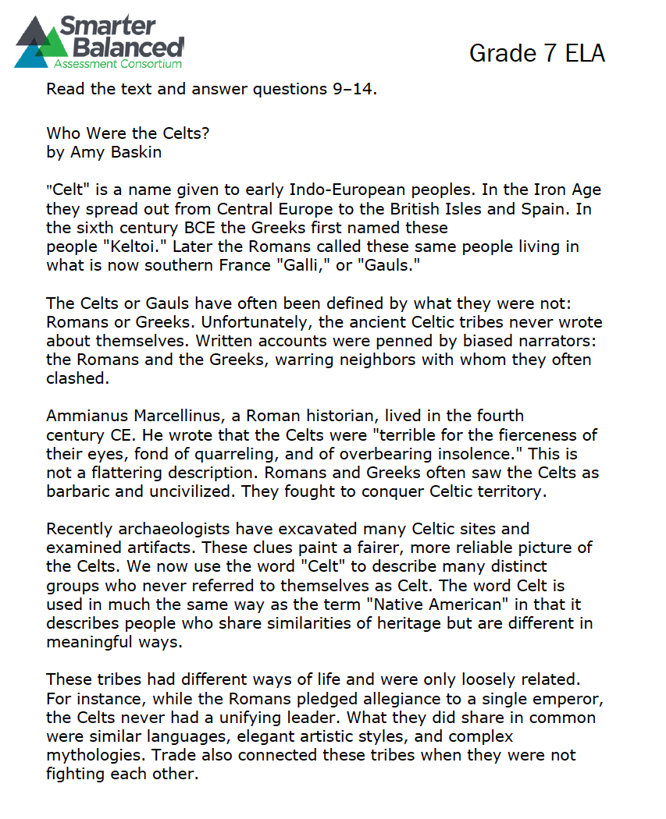

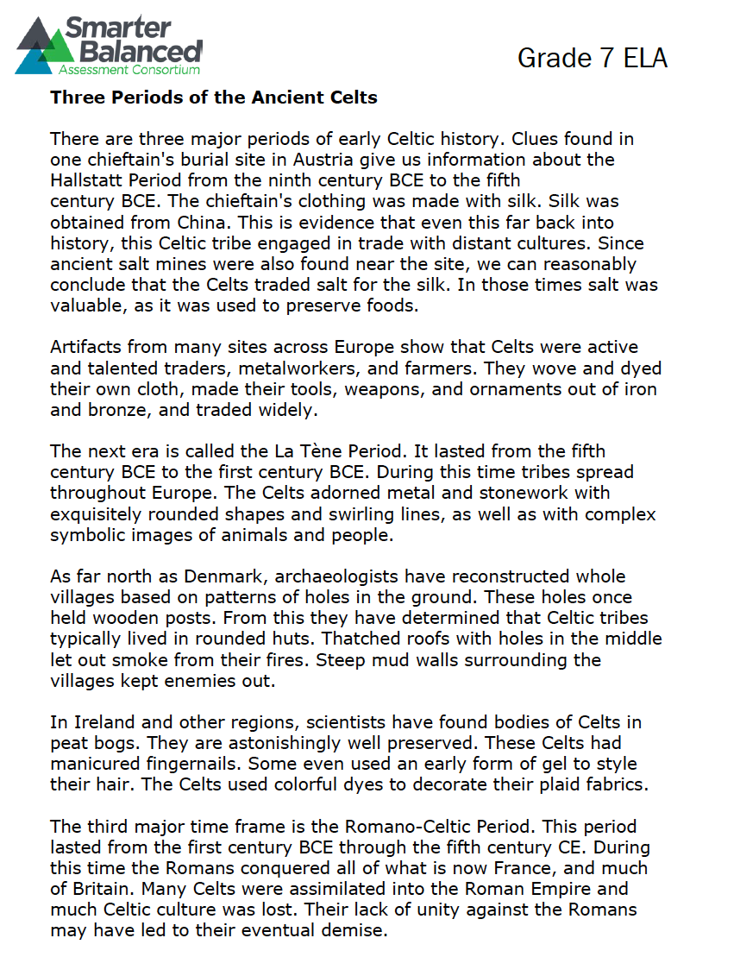

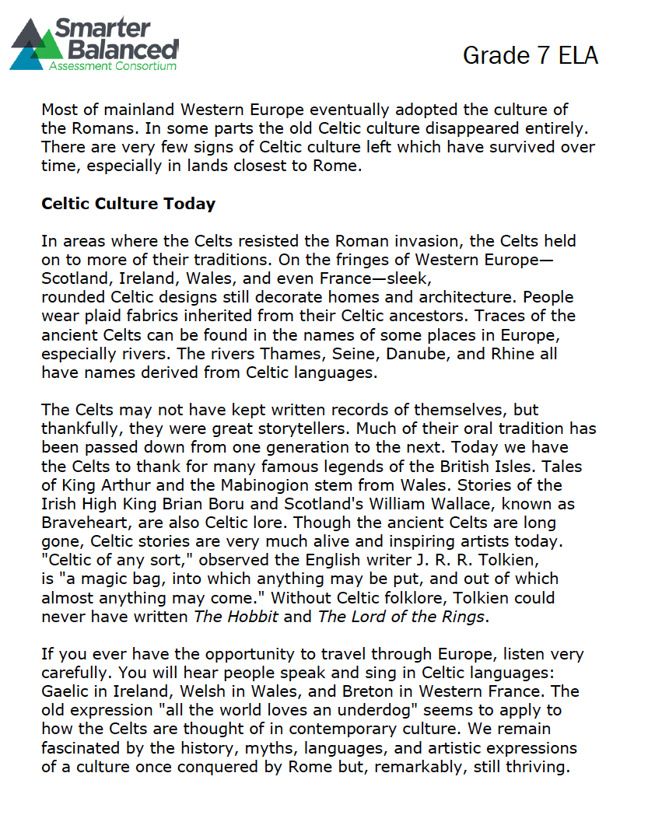

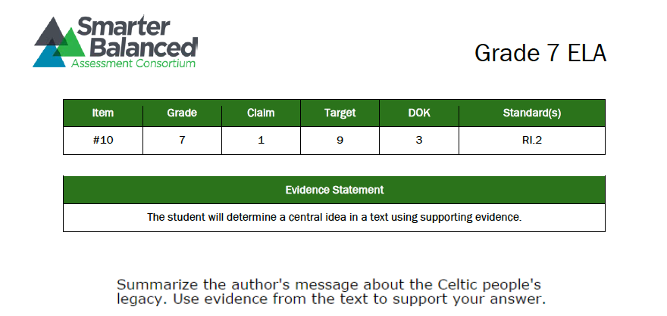

**Type your answer in this box.**

|  |
| --- |
|  |

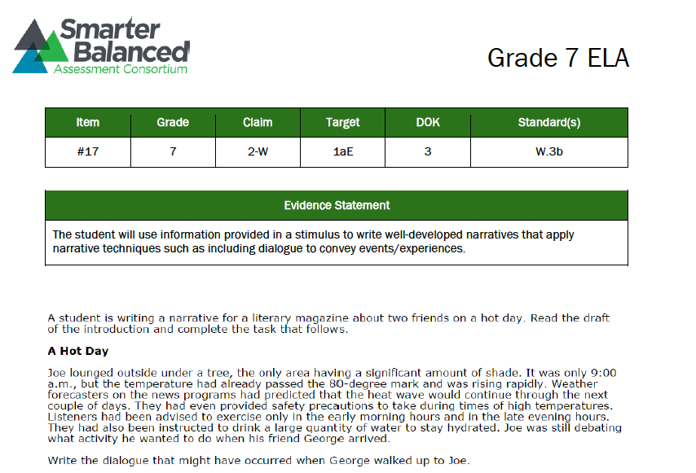

**Type your answer in this box.**

|  |
| --- |
|  |