6 Weeks Opinion Writing Overview

Using the Gradual Release of Responsibility Model of Instruction, we have developed a basic 6-week sequence for successful teaching and learning of a new writing type (genre). This basic 6-week plan includes modeling, shared and guided writing, revision and editing, and finally sharing, publishing, and an on-demand assessment. The sequence is as follows:
Week One: Introduce the writing standards. Model the whole process for the new text type using teacher modeling as well as examination of “mentor texts” or exemplars from published authors. Focus on identifying the elements of the new text type with color coding or labeling.
Week Two: Use shared writing to write a class piece using this text type. Follow the same procedure you are going to ask the students to try on their own. If there is a particular graphic organizer, for example, use it during week 2. Develop a “how to” chart for reference as you walk the students through the steps.
Weeks Three-Four: Guide students through drafting 3 or more pieces. Supply varying levels of support depending on student need. Focus on choice of topics as possible. Provide mini-lessons on specific skills as needed.
Week Five: Have students choose one piece to revise and edit. Teach mini-lessons as needed using student writing as well as anchor papers. Provide time for peer conferencing as well as one-on-one teacher conferencing as possible.
Week Six: Help students publish their favorite piece to final copy. Set aside time to share published pieces with an audience. Give feedback both from teacher and peers. Conduct an on-demand prompt if time allows.
The specific 6-week plan for focusing on Opinion Writing is in the unit planner separate from this document.

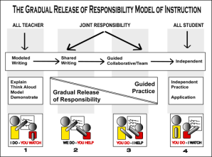

This is the Gradual Release Model of Instruction incorporated in these lessons.

* Please note: teachers may find that their students need more than two weeks of guided practice to learn to write a particular genre. The teacher will know that it is time to move on to teaching revision and editing when the students have completed at least 3 complete drafts of a writing type. Some forms of writing take longer than others to complete, so this section of the sequence may take longer.
CCSS Unit Planner for Opinion/Argument Writing K-5
“Begin with the end in mind.”
Grade |  |  | Topic(s):
PLANNING | Big, Enduring Ideas and Concepts:  Use “Look At” document for content standards. http://www.cde.ca.gov/ci/cr/cf/grlevelcurriculum.asp
 | Content Standards
Authentic Mode for Publishing/Sharing:
Format (something you would see in the real world— magazine, brochure, webpage, poster etc.)
Style is covered under Writing: W 4 and publishing is in W6 and Speaking and Listening: SL 1-5.
 | CCSS Grade level writing expectations:
 | Writing Standard 1: Opinion/Argument and others
 | Authentic Audience (parents, classroom website/blog, other grade level peers, little buddies, library display, author’s tea, etc.) Audience is covered in Writing: W 4 and W10; and Speaking and Listening: SL4.
Assessment: district rubric, peer commentary, portfolio, self reflection
Revision is covered under Writing: W5, and peer assessment under Speaking and Listening: SL 1 and 4.
CCSS Unit Planner for Informative Writing continued
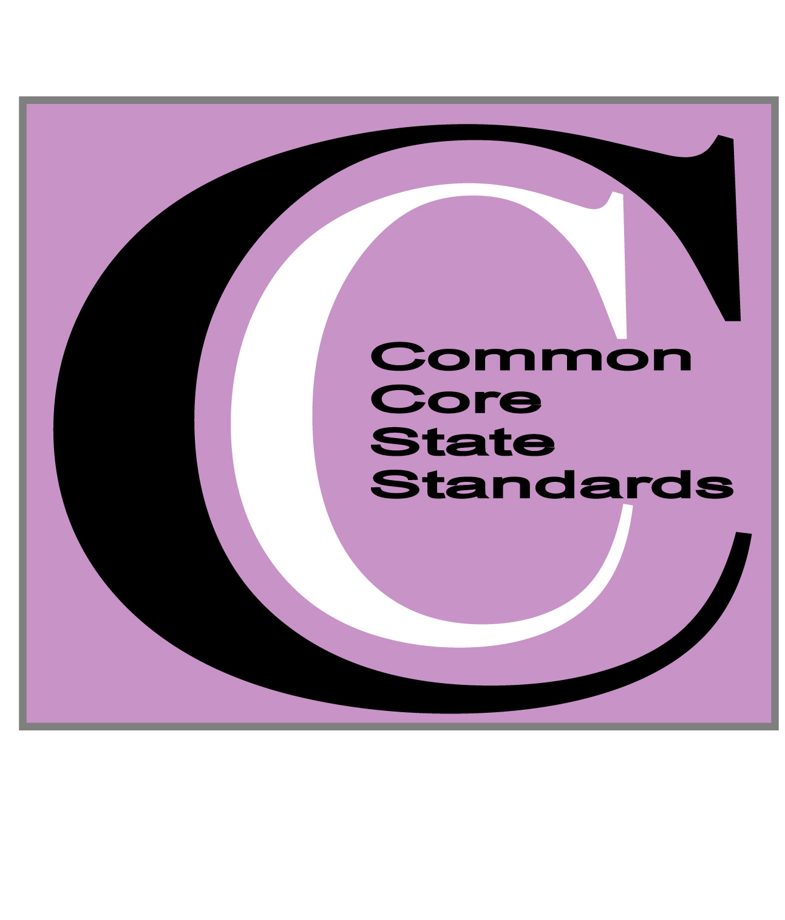
READING and RESEARCH SOURCES | Possible Sources: INTERNET  Internet resources are covered under Reading: RI7 and Writing: W6.
Possible Sources: TEXTBOOKS/BOOKS
Other resources are covered under Reading: RL 1-10, RI 9 and Writing: W6-8.
Possible Sources: OTHER
(Guest speakers, community organizations, skype with expert etc.)
Interaction with people & resources is covered under Writing: W6 and Speaking and Listening: SL 1,2,3.
Evaluating Sources and Resources
Include a lesson on how to evaluate websites and conduct effective website searches. http://www.schrockguide.net/critical-evaluation.html Excellent source of website evaluation lessons
Evaluation of resources is covered under Reading: R 7,8,9.
6-Week Plan: Backwards Planning for Success in Opinion/Argument Writing
WEEK 1
Week 1 Dates: ______________________ Number of lesson periods ________
During Reading | Pages from Handbook ______  Read Text Exemplars for Opinion/Argument: editorials, book reviews, read alouds/picture books etc.  Identify elements: opinion/claim, reasons given, linking words used, facts included etc. Try color coding or labeling.
During Writing | Pages from Handbook _____  Model writing a full piece. Label the parts of your piece showing elements of Opinion/Argument writing. Make sure to cover those listed on your rubric.  Encourage “quick tries” with elements of writing you are modeling.
6-Week Plan: Backwards Planning for Success in Opinion/Argument Writing
WEEK 2
Week 2 Dates: ______________________ Number of lesson periods ________
During Reading | Pages from Handbook ______  Teach Reading Informational Text Standard 8. Have students locate and discuss reasons authors use to support a position or opinion in text. Try a “tree map” for notetaking.
During Writing | Pages from Handbook ______  Shared Writing of an Opinion/Argument piece about a sub topic of the overall unit with class input. Walk through the process, encourage input with whiteboards or small group discussion, create a “how to” chart. Continue to encourage “quick tries.”
6-Week Plan: Backwards Planning for Success in Opinion/Argument Writing
WEEKS 3-4
Weeks 3-4 Dates: ___________________ Number of lesson periods ________
During Reading | Students read and research about topics, issues, or pieces of literature of their own choosing. Students identify reasons and evidence to use in writing their opinion/argument pieces and take notes.  Use shared reading to teach students close reading strategies and asking and answering text dependent questions.
During Writing | Pages from Handbook ______  Guided Writing: students choose a focus, plan, and draft one or more pieces following the process modeled in weeks 1-2.  Mini-lessons: provide short targeted lessons on aspects of Opinion/Argument writing as needed.  Write anchor papers with students to match their rubric.

6-Week Plan: Backwards Planning for Success in Opinion/Argument Writing
WEEKS 5-6
Weeks 5-6 Dates: ______________________ Number of lesson periods _____
During Reading | Students continue to read and research as needed. Consider giving more time for writing during the last couple of weeks of the unit so that students have time to revise, edit, word process, and create visuals for their pieces.
During Writing | Pages from Handbook _______  Revise: students select one piece to take to publication. Conduct mini-lessons on revision using student work, conference with individuals as possible.  Edit and Publish: use self and peer techniques as well as word processing to edit and publish.  “Dress Rehearsal”: conduct a trial of an on-demand write if time before assessment (page __).

