Name: ___________________________________________________________

When you have mastered the skill, color in the box!
I can find letters, words, and sentences.  a b c dog cat    The cat sat next to the dog. | I can hear sounds in words.  oooooo  TOOT |         a e i o u  I know the short and long vowel sounds. | I can make rhyming words.  cat  bat  hat
I can read my sight words.  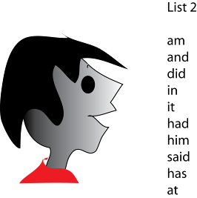 | I can read compound words and contractions.  Baseball  Bathtub  Can’t  Won’t  Didn’t | I can read words with special endings.    look  looked  looking | I know word families.  --in  fin, pin, win, chin, grin, skin, spin, thin, twin  in---  inside, into
I can understand the order of a story.  beginning middle end | I can tell who is in a story and what happened in a story. | I can talk about the plot, setting, and characters in a story and put the events in order. | I use describing words.
I print my letters neatly and leave spaces between words.  write neatly  leave spaces  between words | Using my senses, I can write about something real with describing words.  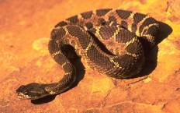  snake  diamond  pattern  brown  and white  slithers  scary | I can blend sounds.  sl + ip = slip  bl + ue = blue
Adapted from www.kellyskindergarten.com/

bin, fin, pin, sin, win, chin, grin, shin, skin, spin, thin, twin

Name: ___________________________________________________________
When you have mastered the skill, color in the box!
name  I can find letters, words, and sentences. | cat hat  I can rhyme! | Aa Bb Cc  I know my letters! | b c  I know my letter sounds!
a e  i  o u  I know my  short vowels! | a b c d e  f g h i j k  l m n o p  q r s t u  v w x y z  I can write  my letters! | I can tie  my shoes! |   Pl…ay  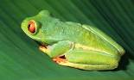  Fr…og  I can  blend words!!
I can read the  kinder  sight words | I know my  numbers 0-10! | I know my  numbers  0-30!! | 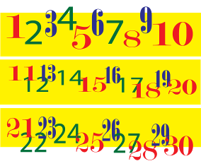  I can put  My numbers  in order 0-30.
27…28…29…  30!  I can count to 30! | 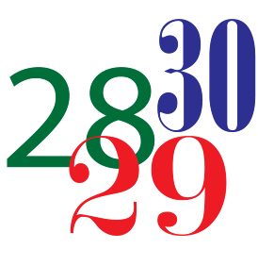  I know my  7 shapes! | 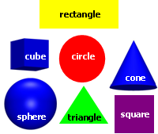
Adapted from www.kellyskindergarten.com/

