Generic Version: Just add your favorite pictures and change highlighted text to indicate your subject.

Teacher Version
Grade | 1 | Title/Subject | Type your title here
Included in this packet:
- Teacher directions
- Student prompt and directions
- A visual for from which students create a narrative

Overview
Students will write a personal narrative describing any event they recall at home or school. On day 1 students will have the opportunity to discuss the events at school or home and choose one they want to write about. Then they will talk about this event with a peer and plan their narrative. On day 2 they will draft the full narrative. On day 3 they are reminded to reread their narrative and revise for elements of quality narratives, then edit their work and if they choose, produce a final copy.

Process:

Day 1: Planning - Up to 60 minutes
Step 1: Discuss events of the school year
Brainstorm a list of all the possible events with students. Offer some lead suggestions, such as birthdays, first day of school, moving, etc. Have students choose one of the events to write about in their narrative.
Step 2: Discuss storyline possibilities with peers
Tell students to take turns sharing ideas for a storyline. Remind them that narratives have characters, settings or situations, and beginnings, middle and end. Have them discuss possible ideas for their stories with each other. Then they can take turns with a partner telling their story based on the event they chose to write about.
Step 3: Planning
Distribute blank paper to the students. Tell them to plan their narrative using whichever techniques you have taught them that they prefer. This may include drawing pictures for beginning, middle and end; a story map or graphic organizer; etc. You may remind them of the strategies for planning, but DO NOT provide a pre-printed graphic organizer. students need to create their own plans for this on-demand writing task.

Teacher Version
Grade | 1 | Title/Subject | Type your title here

Day 2: Writing a Draft - Up to 60 minutes
Step 1: Review of process
Tell students that they will now write a first draft of their story. You may review the process for writing a story by going over the student-friendly checklist included with this prompt.
Step 2: Drafting
Tell the students they will now write their stories. Remind them that it is helpful to skip lines to make it easier to revise their work later. Maintain a quiet atmosphere during the writing period so that all students may concentrate on their own work.

Day 3: Revising and Editing - Up to 60 minutes
Step 1: Review of process
Tell students that they will now revise and edit their story. You may use the student prompt to remind them of the elements needed in a quality narrative. If there is time, students may choose to type or re-copy their work to a final draft, or they may just make corrections on their first draft.
Step 2: Revise and Edit
Provide students with up to an hour to finish a final draft. When they are finished, collect all pieces of their work: planning page, drafting pages, and final draft.

Teacher Directions for Scoring Rubric:

Use the narrative writing rubric to score the work. Enter scores in assessment log

Grade | 1 | Narrative Writing Rubric

Level | NARRATIVE WRITING | LANGUAGE CONVENTIONS | WITH GUIDANCE and SUPPORT  FROM ADULTS
4  Exceeds | - Meets all expectations in level 3  - Uses many descriptive words  - Writes many complete and varied sentences  - Has sequence of events which is clear and well organized  - May attempt to add dialogue | Mostly correct use of language conventions, and some above grade level skills used, for example:  - Meets all expectations in level 3  - Consistently spells grade level appropriate words correctly  - Capitalizes holidays, product names, and geographic names  - Uses an apostrophe to form contractions and possessives | 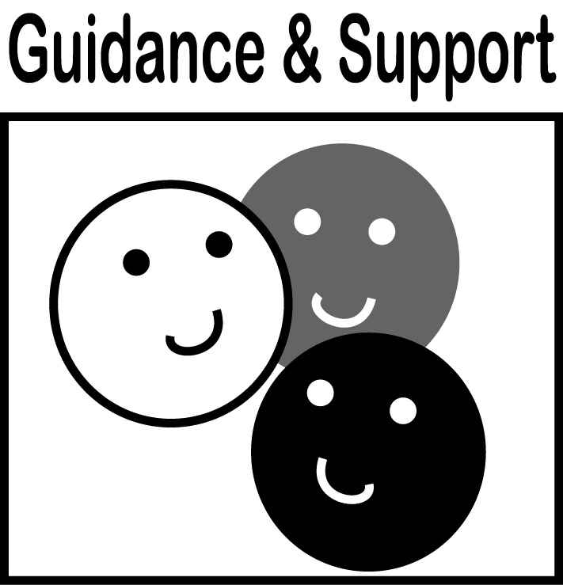  Level of guidance and support from adults before writing:  Check off what was done before the student wrote the piece being scored.  - Discussion  - Read aloud or shared reading  - Drawing  - Vocabulary word bank  - Shared or interactive writing  - Graphic organizer  - Language frames
3  Meets | NARRATIVE WRITING (W3)  - Writes narratives in which include two or more appropriately sequenced events  - Includes some details regarding what happens  - Uses temporal words to signal event order  - Provides some sense of closure  WRITING PROCESS (W5-W8)  - WGASFA * Adds details to strengthen writing as needed (W5)  - WGASFA * Uses a variety of digital tools to write and publish writing (W6)  - WGASFA * Recalls information from experiences or gathers information from provided sources to answer a question (W8) | Adequate use of correct sentence formation, punctuation, capitalization, grammar usage and spelling for grade level, for example:  - Prints all upper- and lowercase letters (L1a)  - Produce and expand complete simple and compound declarative, interrogative, imperative, and exclamatory sentences in response to prompts (L1j)  - Capitalizes dates and names of people (L2a)  - Use end punctuation for sentences (L2b)  - Use commas in dates and to separate single words in a series (L2c)  - Use conventional spelling for words with common spelling patterns and for frequently occurring irregular words (L2d)  - Spells untaught words phonetically (L2e)
2  Almost Meets | - Includes only one or two sequenced events  - Does not include closure or closure is unclear  - WGASFA * Adds few details or order is confusing  - WGASFA * Does not use temporal words  - Writing may rely on copying from a patterned sentence (s) and sound like a list | Limited use of correct sentence formation, punctuation, capitalization, grammar usage and spelling for grade level, for example:  - Writes most uppercase and lowercase letters correctly  - Writes mostly simple sentences, and may rely on patterned sentences to write  - Uses some end punctuation marks correctly  - Spells some words phonetically
1  Does Not Meet | - Dictates narrative, but makes little attempt to write it  - Recounts only one event  - Provides no details  - Has confusing sequence of events | Infrequent use of correct sentence formation, punctuation, capitalization, grammar usage and spelling for grade level, for example:  - Makes no or few attempts at correct spelling  - Has many errors in capitalization  - Writes no or few complete sentences  - Makes no or few attempts at end punctuation
- WGASFA: “with guidance and support from adults”
This rubric was adapted from rubrics at sbusd.org and information from Smarter Balanced Assessments (www.smarterbalanced.org) using the California Common Core Standards at www.cde.ca.gov.

Student Version
Grade | 1 | Title/Subject | Student Rubric

Student Prompt:
Write your prompt here. This is a rubric to remind you of the elements to include in your story. Color in the face on the right as you include this element in your story.
Content |  | Elements | Self
Content | 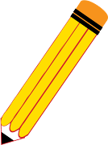 | I wrote a story about something that happened. | 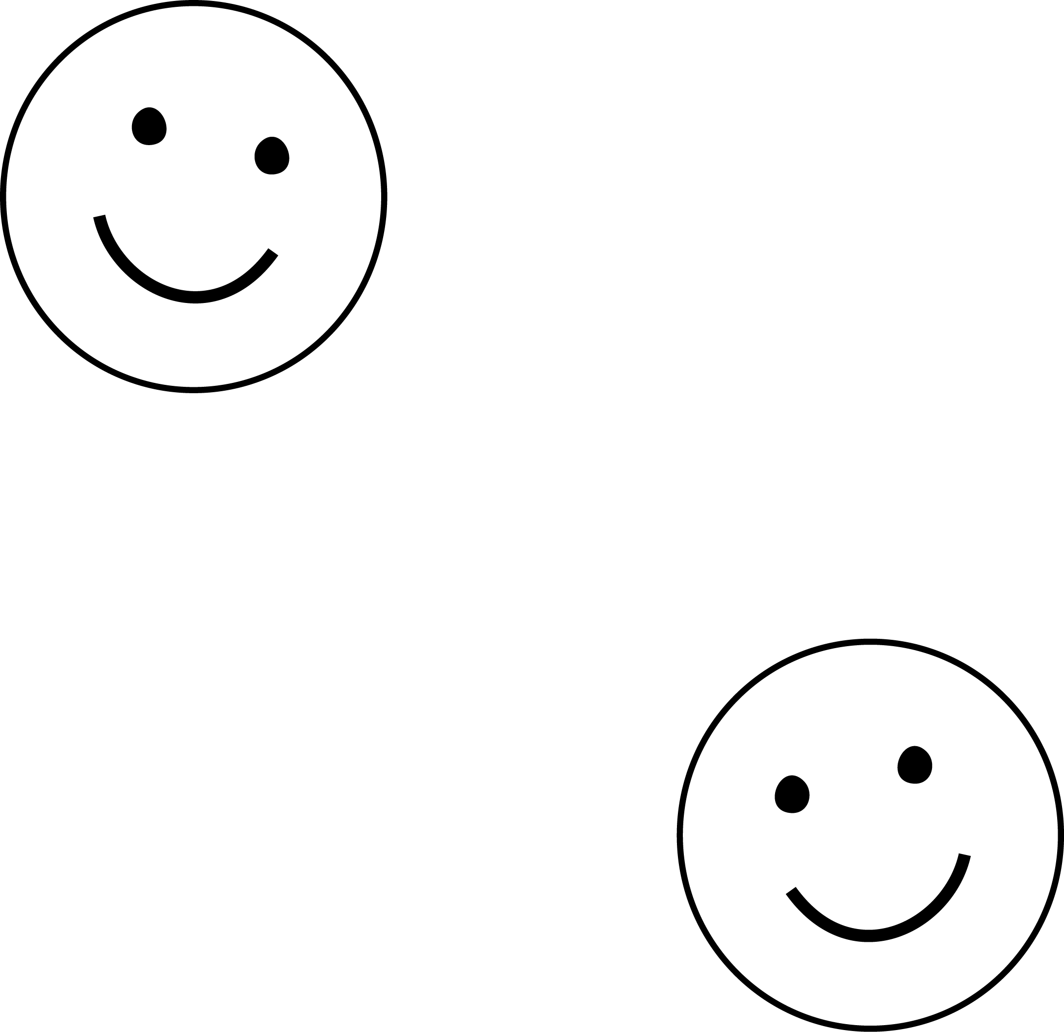
Content | 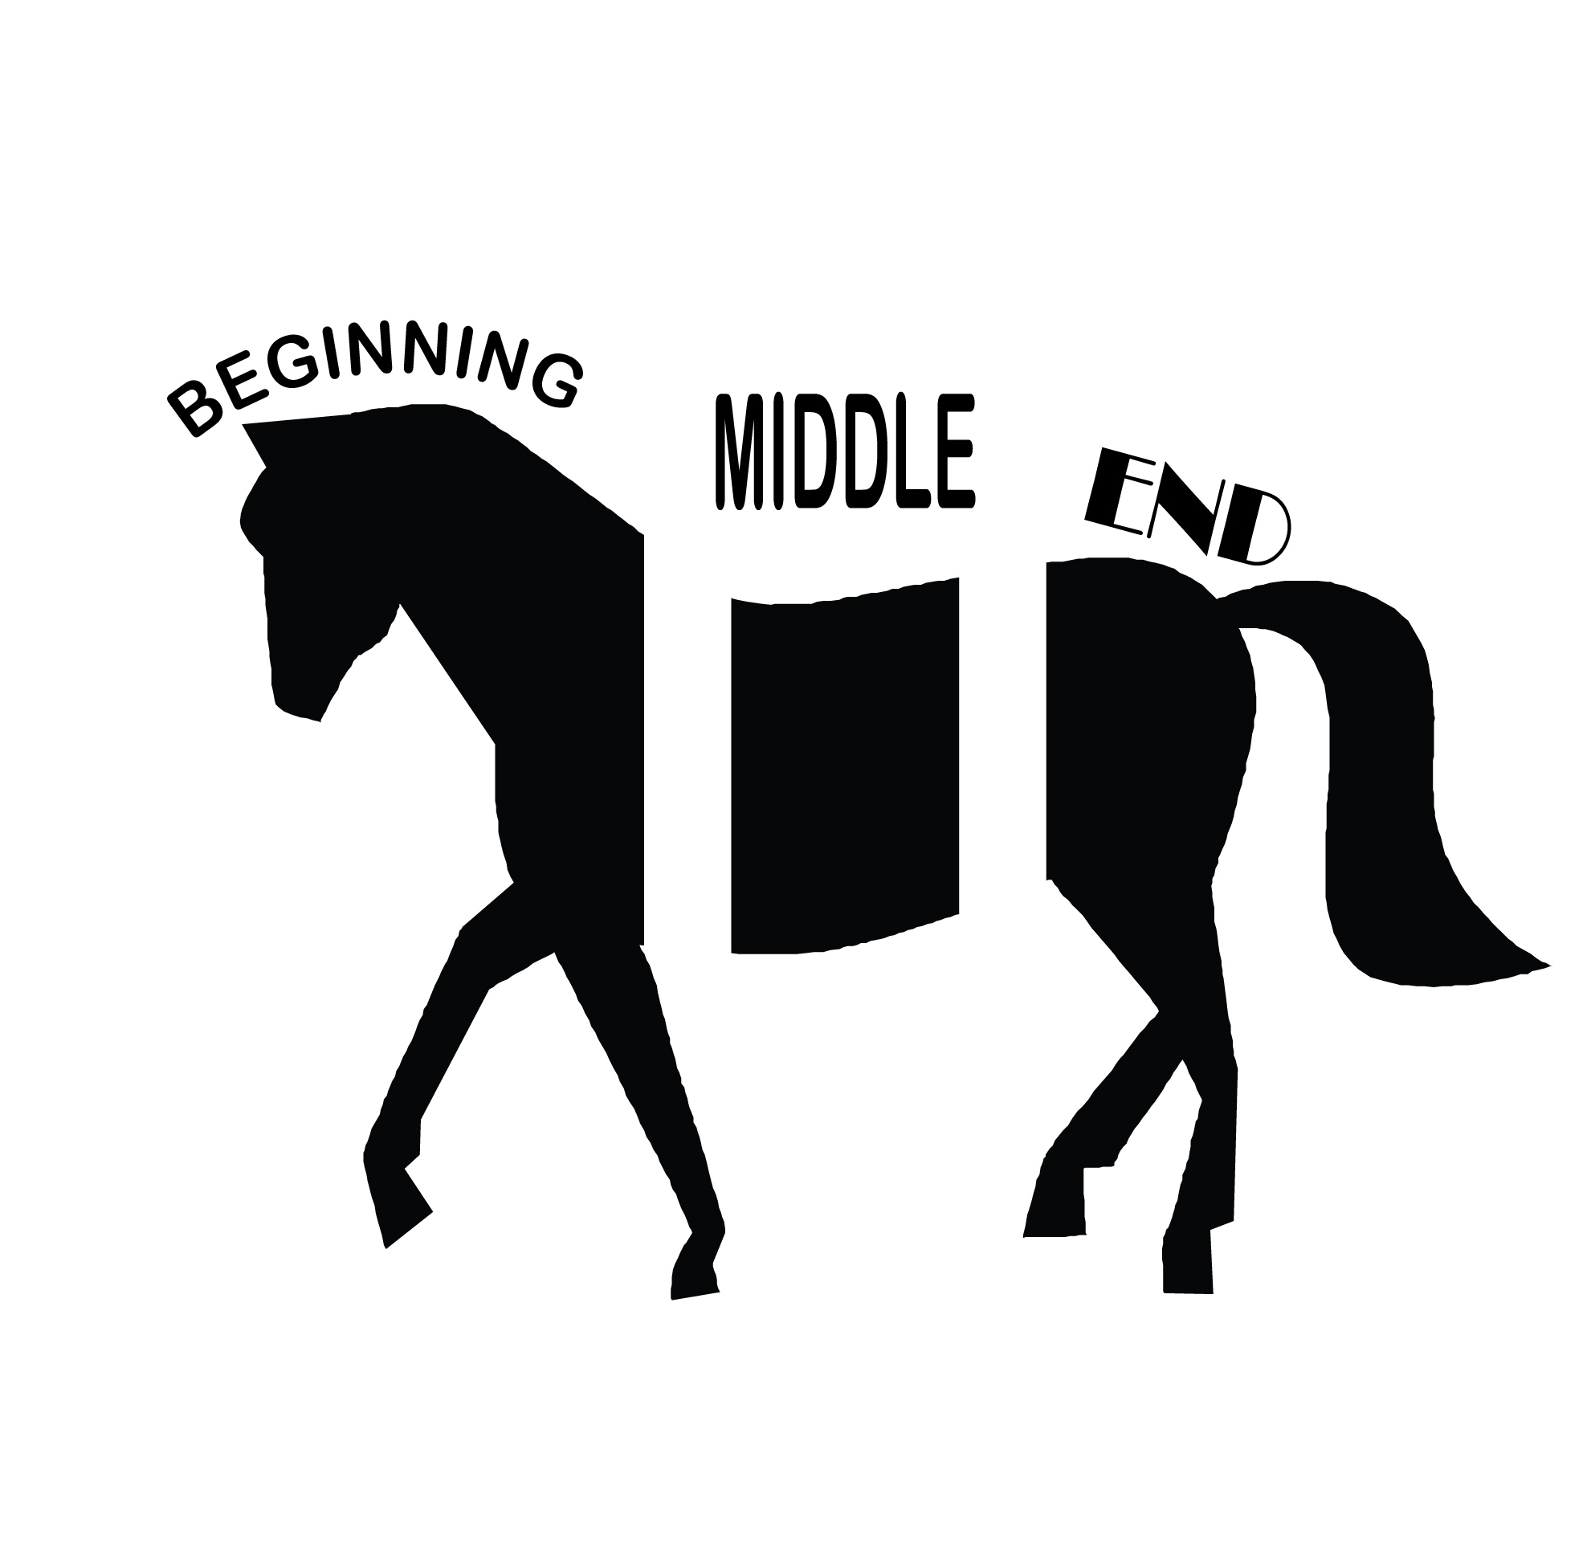 | I wrote about what happened in order: beginning, middle, end.
Content | 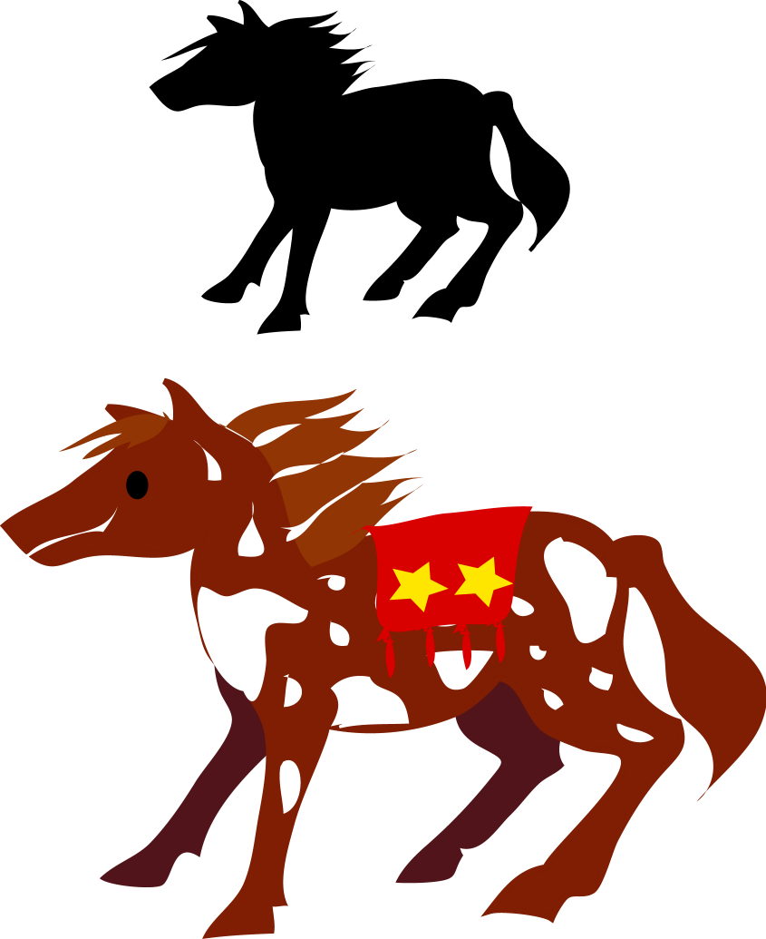 | I added details to my writing to tell my reader about what happened.
Content | ①➔②⬅➔③ | I used sequence words.  First, before, next, after, then, last
Content |  | I wrote an ending to my story.
Conventions | Capitals are first! | I wrote a capital to start every sentence and for names, dates, and the pronoun “I”.
Conventions |  | I used all the words I know to help me spell well.
Conventions | This is the end. | I ended each sentence with an end punctuation mark.  • ! ?

Add your pictures here.

