Generic Version: Just add your favorite pictures and change highlighted text to indicate your subject.

Teacher Version
Grade | 2 | Title/Subject | Fictional Event
Included in this packet:
- Teacher directions
- Student prompt

Overview
Students will write a fictional narrative about what would happen if they came to school one day and something weird happened. On day 1 they have the opportunity to discuss possible storylines with a peer and plan their narrative. On day 2 they draft the full narrative. On day 3 they are reminded to reread the narrative and revise for elements of quality narratives, then edit their work and if time, produce a final copy.

Process:

Day 1: Planning - Up to 60 minutes
Step 1: Discuss storyline possibilities with peers
Tell students to imagine they come to school one day and something weird happens. Examples might include desks start to float for half an hour, or their pencils turn into mice, etc. They must describe the event and write a narrative about what happens. Remind them that narratives have characters, settings or situations, and plot.
Step 2: Brainstorm ideas
Have them discuss possible ideas for their events and their stories with each other.
Brainstorm a list of possible events the students can write about.
Brainstorm a list of places in school that could make the setting.
Allow students to talk about possible storylines but don’t list their ideas.
Step 3: Planning
Distribute blank paper to the students. Have them draw or create their own plan for their story. Tell them to plan their narrative using whichever techniques you have taught them that they prefer. This may include storyboarding, a story map or graphic organizer, story hill, etc. You may remind them of the strategies for planning, but DO NOT provide a pre-printed graphic organizer. They need to create their own plans for this on-demand writing task.

Teacher Version
Grade | 2 | Title/Subject | Fictional Event

Day 2: Writing a Draft - Up to 60 minutes
Step 4: Review of process
Tell students that they will now write a first draft of their story. You may review the process for writing a story by going over the student-friendly directions included with this prompt.
Step 5: Drafting
Tell the students they will now have up to 50 minutes to write their stories. Remind them that it is helpful to skip lines to make it easier to revise their work later. Maintain a quiet atmosphere during the writing period so that all students may concentrate on their own work.
Day 3: Revise and Edit - Up to 60 minutes
Step 6: Revise and Edit
Provide students with up to an hour to finish a final draft. You may remind them to reread for content such as detail, sequence words, etc. You may also remind them to edit and check for capitals, punctuation, and spelling. They may correct their draft or write a new final draft as they choose. When they are finished, collect all pieces of their work: planning page, drafting pages, and final draft.

Teacher Directions for Scoring Rubric:

Use the narrative writing rubric to score the work. Enter scores in assessment log.

Grade | 2 | Narrative Writing Rubric

Level | NARRATIVE WRITING | LANGUAGE CONVENTIONS | WITH GUIDANCE and SUPPORT  FROM ADULTS
4  Exceeds | - Meets all expectations in level 3  - Writes several well-developed details to describe actions, thoughts and feelings  - Event sequence unfolds naturally  - Uses dialogue in story | Mostly correct use of language conventions, and some above grade level skills used, for example:  - Meets all expectations in level 3  - Uses commas and quotation marks in dialogue.  - Spells grade level appropriate words correctly  - Chooses words and phrases for effect. | 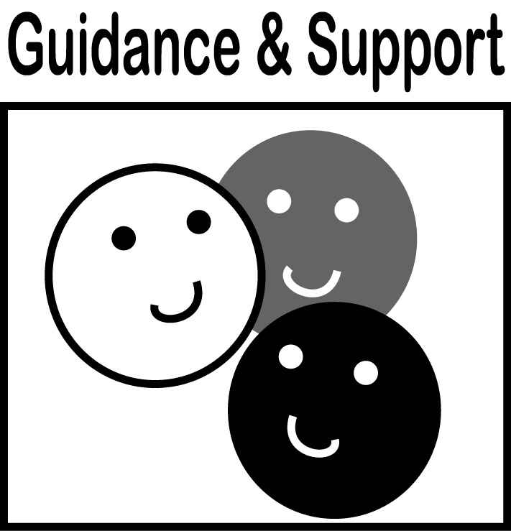  Level of guidance and support from adults before writing:  Check off what was done before the student wrote the piece being scored.  - Discussion  - Read aloud or shared reading  - Drawing  - Vocabulary word bank  - Shared or interactive writing  - Graphic organizer  - Language frames
3  Meets | NARRATIVE WRITING (W3)  - Narrative recounts a well-elaborated event or short sequence of events  - Includes details to describe actions, thoughts, or feelings  - Uses temporal words to signal event order  - Provides a sense of closure  WRITING PROCESS (W5-W8)  - WGASFA* Adds details and edits to strengthen writing as needed (W5)  - WGASFA* Uses a variety of digital tools to write and publish writing (W6)  - Recalls information from experiences or gathers information from provided sources to answer a question (W8) | Adequate use of correct sentence formation, punctuation, capitalization, grammar usage and spelling for grade level, for example:  - Produces, expands, and rearranges complete simple and compound sentences (L1f)  - Creates readable documents with legible print (L1g)  - Capitalizes holidays, product names, and geographic names (L2a)  - Uses commas in greetings and closings of letters (L2b)  - Uses an apostrophe to form contractions and frequently occurring possessives (L2c)  - Consults reference materials as needed to check and correct spellings (L2e)  - Spells grade level appropriate words correctly most of the time, uses grade level appropriate phonetic spelling to write unfamiliar words  - Uses knowledge of language and its conventions when writing (L3)
2  Almost Meets | - Writes about an event but does not elaborate  - Provides some details about actions but does not include thoughts or feelings about events  - Uses some temporal words, but sequence may be confusing  - Provides a sense of closure but may not be well related  - WGASFA* adds few details and does little editing to strengthen writing | Limited use of correct sentence formation, punctuation, capitalization, grammar usage and spelling for grade level, for example:  - Writes simple sentences, and some incomplete sentences  - Capitalizes first letter, and I, but not proper names  - Uses some punctuation correctly  - Spells some grade level appropriate words, and uses some phonetic spellings
1  Does Not Meet | - Story has only one event and may be incomplete  - Provides very few details or descriptions  - Event order is confusing or missing steps  - Sense of closure is missing or unrelated | Infrequent use of correct sentence formation, punctuation, capitalization, grammar usage and spelling for grade level, for example:  - Makes few attempts at correct spelling  - Has many errors in capitalization  - Writes few complete sentences or only simple patterned sentences  - Makes few attempts at correct punctuation

- WGASFA: “with guidance and support from adults”
This rubric was adapted from rubrics at sbusd.org and information from Smarter Balanced Assessments (www.smarterbalanced.org) using the California Common Core Standards at www.cde.ca.gov.

Student Version
Grade | 2 | Title/Subject | Fictional Event
Student Prompt:
Write your prompt here. Create a narrative which shows what might happen. Include all of the things you’ve learned about narrative writing.
Content |     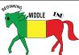   | Elements | Self
Content |  | I wrote a story about something that happened. | 
Content |  | I wrote about what happened in order: beginning, middle, end.
Content |  | I wrote details to describe actions, thoughts, and feelings.
Content | ①➔②⬅➔③ | I used sequence words.  First, before, next, after, then, last or finally
Content |  | I wrote an ending to my story.
Conventions | Capitals are first! | I wrote a capital to start every sentence and for names, dates, holidays, geographic names, and the pronoun “I”.
Conventions | Can’t | I used an apostrophe for words like can’t and don’t.
Conventions | This is the end. | I ended each sentence with a punctuation mark.  • ! ?
Conventions |  | I tried to spell my words correctly and used a dictionary or sight words to help me.

Add pictures or information here.

