Generic Version: Just add your favorite pictures and change highlighted text to indicate your subject.

Teacher Version
Grade | 3 | Title/Subject | Creative Story about Fictional Events
Included in this packet:
- Teacher directions
- Student prompt

Overview
Students will write a fictional narrative about a fictional event at school. On day 1 teachers will brainstorm with students about possible fictional events. Students will have time to discuss and plan a story of their own. On day 2 they will draft the full narrative. On day 3 they are reminded to reread the narrative and revise for elements of quality narratives, then edit their work and if time, produce a final copy.

Process:

Day 1: Planning - Up to 60 minutes
Step 1: Display images and choose
With a document camera display the prompt. Make a T-chart on a piece of chart paper. Brainstorm with the group possible fictional events that could happen for them at school.

Step 2: Discuss storyline possibilities with peers
Tell students to take turns sharing ideas for a storyline based on their choice of possible events. Remind them that narratives have characters, settings or situations, and plot. Have them discuss possible ideas for their stories with each other.
Step 3: Planning
Distribute blank paper to the students. Tell them to plan their narrative using whichever techniques you have taught them that they prefer. This may include storyboarding, a storymap or graphic organizer, storyhill, etc. You may remind them of the strategies for planning, but DO NOT provide a pre-printed graphic organizer. They need to create their own plans for this on-demand writing task.

Teacher Version
Grade | 3 | Title/Subject | Creative Story about Fictional Events

Day 2: Writing a Draft - Up to 60 minutes
Step 1: Review of process
Tell students that they will now write a first draft of their story. You may review the process for writing a story by going over the student-friendly directions included with this prompt.
Step 2: Drafting
Tell the students they will now have up to 50 minutes to write their stories. Remind them that it is helpful to skip lines to make it easier to revise their work later. Maintain a quiet atmosphere during the writing period so that all students may concentrate on their own work.

Day 3: Revising and Editing - Up to 60 minutes
Step 1: Review of process
Tell students that they will now have up to an hour to revise and edit their story. You may use the student prompt to remind them of the elements needed in a quality narrative. If there is time, students may choose to type or re-copy their work to a final draft, or they may just make corrections on their first draft.
Step 2: Revise and Edit
Provide students with up to an hour to finish a final draft. When they are finished, collect all pieces of their work: planning page, drafting pages, and final draft.

Teacher Directions for Scoring Rubric:

Use the narrative writing rubric to score the work. Enter scores in assessment log.

Grade | 3 | Narrative Writing Rubric

Level | NARRATIVE WRITING/PROCESS | LANGUAGE CONVENTIONS | WITH GUIDANCE and SUPPORT  FROM ADULTS
4  Exceeds | - Meets all expectations in level 3  - Uses a variety of transitional words and phrases to manage sequence of events  - Effective use of concrete, sensory, and figurative language | Mostly correct use of language conventions, and some above grade level skills used, for example:  - Meets all expectations in level 3  - Uses commas in direct quotations, and apostrophes in possessive case of nouns and in contractions when appropriate  - Uses underlining, quotation marks or italics to identify titles of documents | 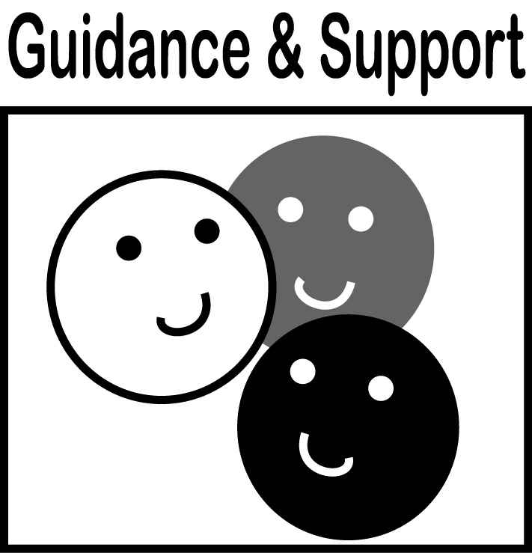  Level of guidance and support from adults before writing:  Check off what was done before the student wrote the piece being scored.  - Discussion  - Read aloud or shared reading  - Drawing  - Vocabulary word bank  - Shared or interactive writing  - Graphic organizer  - Language frames
3  Meets | NARRATIVE WRITING  - Establishes a situation and introduces a narrator and/or characters (W3a)  - Organizes an event sequence that unfolds naturally (W3a)  - Uses dialogue and descriptions of actions, thoughts, and feelings to develop experiences and events or show the response of characters to situations (W3b)  - Uses temporal words and phrases to signal event order (W3c)  - Provides a sense of closure (W3d)  - Uses sensory, concrete and figurative language  WRITING PROCESS (W5 - W8)  - WGASFA* Has clearly planned writing with organized notes, and shows evidence of revision and editing during writing process (W5)  - WGASFA* Uses technology and keyboarding skills (W6)  - Conducts research (W7)  - Uses sources such as, print and internet to gather evidence (W 8)  - Takes brief notes on sources and groups into categories (W8) | Adequate use of correct sentence formation, punctuation, capitalization, grammar usage and spelling for grade level, for example:  - Uses a variation of simple, compound, and complex sentences (L1k)  - Uses subject/verb agreement, pronouns, adjectives, compound words, and articles correctly  - Uses past, present, and future verb tenses correctly (L1g)  - Uses commas in dates, locations, and addresses, items in a series, and quotations in dialogue correctly (L2 b/c)  - Capitalizes titles correctly (L2a)  - Spells high frequency words and adds suffixes correctly, uses spelling patterns from word families  - Forms and uses possessives correctly (L2d)  - Consults reference materials, as needed, to check/correct spelling (L2)  - Uses grade appropriate academic and domain-specific words and phrases (L6)
2  Almost Meets | - Weak introduction and conclusion  - Uneven development of plot, characters, setting  - Uses few transition words, or uses the same throughout  - Some use of sensory, concrete and figurative language  - Has some evidence of planning, organizing notes, and revision | Limited use of correct sentence formation, punctuation, capitalization, grammar usage and spelling for grade level, for example:  - Writes mostly simple sentences with correct punctuation  - Has some correct use of subject/verb agreement, pronouns, adjectives, compound words, and articles  - Uses some correct use of past, present and future verb tenses  - Uses some correct use of punctuation, commas and capitalization  - Has many spelling errors
1  Does Not Meet | - May not introduce characters or events clearly  - Includes few details or descriptions  - Has little evidence of planning, organizing and revision  - Events are disorganized or missing  - Little or no use of sensory, concrete and figurative language | Infrequent use of correct sentence formation, punctuation, capitalization, grammar usage and spelling for grade level, for example:  - Writes incomplete sentences  - Has little or no subject/verb agreement or usage of pronouns, adjectives, compound words and articles  - Uses past, present, and future verb tenses incorrectly  - Has little or no correct punctuation, commas, and capitalization  - Has poor spelling
- WGASFA: “with guidance and support from adults”
This rubric was adapted from rubrics at sbusd.org and information from Smarter Balanced Assessments (www.smarterbalanced.org) using the California Common Core Standards at www.cde.ca.gov.

Student Version
Grade | 3 | Title/Subject | Creative Story about Fictional Events

Student Prompt
Today you will be writing a fictional narrative piece. That means you get to make up the events that occur in this story.

Imagine _________________.
- What happens in your story?
- Who or what is in your story?
- What benefits are there to you?
- What challenges are created for you?
- What challenges are created for your friends or family?

Writing Tips:
- Make a title for your story.
- Introduce your reader to the situation and characters in the story with clear details.
- Use dialogue and description to develop the story and show the responses of the characters to the events.
- Use a variety of temporal words to show the sequence of the story, such as now, then, next, etc. Make sure you use past, present, and future tenses correctly so your reader knows what’s going on and when.
- Use sensory detail (what it looks, sounds, smells like) and descriptions of actions, thoughts, and feelings to help your reader truly experience what is going on in the story.
- Write an ending that flows from the story.
Step 1: Plan
- Plan your characters, plot, and setting before you begin to write.
Step 2: Draft
- Write your draft.
- Read your draft to a partner and make notes about what you want to change.
Step 3: Reread and Revise
- Does it make sense?
- Does it have enough detail?
- Did I use temporal words to show sequence?
Step 4: Edit
  - Capitals at the beginning of sentences and for proper nouns


  - Punctuation: (end points) . ! ?
Good work!
  - Commas , quotation marks “ ”
  - Spelling
  - Complete sentences
Step 5: Final Draft
- Recopy and fix your mistakes.
- Make sure to leave spaces between your words.
- Use your neatest handwriting.

