Generic Version: Just add your favorite pictures and change highlighted text to indicate your subject.

Teacher Version
Grade | 4 | Title/Subject | Creative Story based on picture
Included in this packet:
- Teacher directions
- Student directions and pictures
- Three visuals for students to choose from for creating a narrative

Overview
Students will view three different pictures and will get to choose one to use as a basis for a narrative they will create. On day 1 they have the opportunity to choose a picture, discuss possible storylines with a peer and plan their narrative. On day 2 they draft the full narrative. On day 3 they are reminded to reread the narrative and revise for elements of quality narratives, then edit their work and if time, produce a final copy.

Process:

Day 1: Planning - Up to 60 minutes
Step 1: Display images and choose
With a document camera display each of the images, one at a time. Tell students they will be choosing one of the images to use as a springboard for a narrative they will be creating. When you are finished showing each image, post the images around the classroom and let the students move to the location of the image they chose.
Step 2: Discuss storyline possibilities with peers
Tell students to take turns sharing ideas for a storyline based on the image. Remind them that narratives have characters, settings or situations, and plot. Have them discuss possible ideas for their stories with each other.
Step 3: Planning
Distribute blank paper to the students. Tell them to plan their narrative using whichever techniques you have taught them that they prefer. This may include storyboarding, a storymap or graphic organizer, storyhill, etc. You may remind them of the strategies for planning, but DO NOT provide a pre-printed graphic organizer. They need to create their own plans for this on-demand writing task.

Teacher Version
Grade | 4 | Title/Subject | Creative Story based on picture

Day 2: Writing a Draft - Up to 60 minutes
Step 1: Review of process
Tell students that they will now write a first draft of their story. You may review the process for writing a story by going over the student-friendly directions included with this prompt.
Step 2: Drafting
Tell the students they will now have up to 50 minutes to write their stories. Remind them that it is helpful to skip lines to make it easier to revise their work later. Maintain a quiet atmosphere during the writing period so that all students may concentrate on their own work.

Day 3: Revising and Editing - Up to 60 minutes
Step 1: Review of process
Tell students that they will now have up to an hour to revise and edit their story. You may use the student prompt to remind them of the elements needed in a quality narrative. If there is time, students may choose to type or re-copy their work to a final draft, or they may just make corrections on their first draft.
Step 2: Revise and Edit
Provide students with up to an hour to finish a final draft. When they are finished, collect all pieces of their work: planning page, drafting pages, and final draft.

Teacher Directions for Scoring Rubric:

Use the narrative writing rubric to score the work. Enter scores in ________________.

Grade |  | 4 | Narrative Writing Rubric
Level | NARRATIVE WRITING |  |  | LANGUAGE CONVENTIONS | WITH GUIDANCE and SUPPORT  FROM ADULTS
4  Exceeds | - Meets all expectations set forth in 3  - Uses narrative techniques, such as dialogue, description, and pacing, to develop experiences and events  - Effective use of concrete, sensory, and figurative language |  |  | Mostly correct use of language conventions, and some above grade level skills used, for example:  - Meets all expectations set forth in 3  - Uses underlining, quotation marks, or italics for titles of works  - Recognizes and corrects inappropriate shifts in verb tense. | 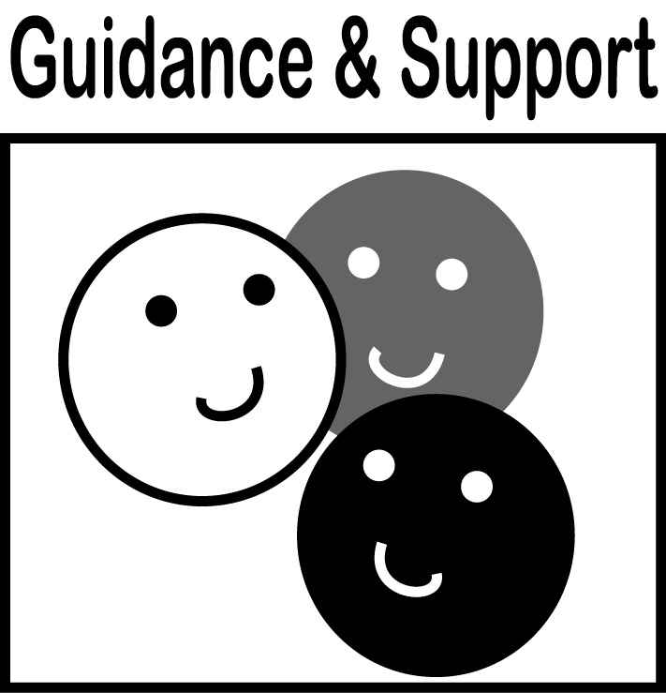  Level of guidance and support from adults before writing:  Check off what was done before the student wrote the piece being scored.  - Discussion  - Read aloud or shared reading  - Drawing  - Vocabulary word bank  - Shared or interactive writing  - Graphic organizer  - Language frames
3  Meets | NARRATIVE WRITING (W3)  - Orients the reader by establishing a situation and introducing a narrator and/or characters (W3a)  - Organizes event sequence that unfolds naturally (W3a)  - Uses dialogue and description to develop experiences and events or show the responses of characters to situations (W3b)  - Uses a variety of transitional words and phrases to manage sequence of events (W3c)  - Uses concrete words and phrases and sensory details to convey experiences and events precisely (W3d)  - Provides a conclusion that follows from the narrated experiences or events (W3e)  WRITING PROCESS (W4-W8)  - Uses clear and coherent writing in multi-paragraph texts that is appropriate to task, purpose, and audience (W4)  - WGASFA* Develops/strengthens writing by planning, revising, editing (W5)  - WGASFA* Uses a variety of digital tools to write and publish writing (W6)  - WGASFA* Can keyboard/ type a minimum of one page in a single sitting (W6)  - Takes notes, paraphrases, and categorizes information, and provides a list of sources (W8)  - Draws evidence from text (W9) |  |  | Adequate use of correct sentence formation, punctuation, capitalization, grammar usage and spelling for grade level, for example:  - Produces complete sentences, recognizing and correcting inappropriate fragments and run-ons (L1f)  - Correctly uses frequently confused words (e.g., to, too, two; there, their) (L1g)  - Writes fluidly and legibly in cursive or joined italics. (L1h)  - Uses correct capitalization (L2a)  - Uses commas and quotation marks to mark direct speech and quotations from a text (L2b)  - Uses a comma before a coordinating conjunction in a compound sentence. (L2c)  - Spells grade-appropriate words correctly, consulting references as needed. (L2d)  - Chooses words and phrases to convey ideas precisely (L3)  - Chooses punctuation for effect (L3)
2  Almost Meets | - Unevenly maintains setting, characters, and plot  - May not write multi-paragraphs  - Little use of concrete words and phrases and sensory details to convey experiences and events precisely (W3d)  - Planning for writing is limited  Uses some linking words/phrases |  |  | Limited use of correct sentence formation, punctuation, capitalization, grammar usage and spelling for grade level, for example:  - Uses some punctuation correctly  - Uses some sentence variety correctly  - Spells most words correctly
1  Does Not Meet | - Has little or no plot, or may be just a series or list of events  - Provides few details or descriptions  - Uses no or few transitions  - Does not write multiple paragraphs  - Planning for writing is absent or disorganized |  |  | Infrequent use of correct sentence formation, punctuation, capitalization, grammar usage and spelling for grade level, for example:  - Many words spelled incorrectly  - Has many errors in capitalization  - Writes few complete sentences or only simple sentences  - Punctuation includes many errors or is missing
- WGASFA: “with guidance and support from adults”
This rubric was adapted from rubrics at sbusd.org and information from Smarter Balanced Assessments (www.smarterbalanced.org) using the California Common Core Standards at www.cde.ca.gov.

Student Version
Grade | 4 | Title/Subject | Student Rubric

Student Prompt:
Choose one of the pictures to write a story about. Look carefully at the pictures and then think of an idea for a story that could be told about what is going on in the pictures. Write a story to go with the picture which includes all of the things you’ve learned about narrative writing.
Writing Tips:
- Make a title for your story.
- Introduce the reader to the situation and characters in the story with clear details.
- Use dialogue and description to develop the story and show the responses of the characters to the events.
- Use a variety of transition words, phrases and clauses to manage the sequence of the story.
- Use concrete words and phrases and sensory detail to help the reader truly experience what is going on in the story.
- Write an ending that flows from the story.
Step 1: Plan
- Plan your characters, plot, and setting before you begin to write.
Step 2: Draft
- Write your draft.
- Read your draft to a partner and make notes about what you want to change.
Step 3: Reread and Revise
- Does it make sense?
- Does it have enough interest, detail?
- Are the time sequences and transitions clear?
Step 4: Edit
  - Capitals at the beginning of sentences and for proper nouns


  - Punctuation: (end points) . ! ?
Good work!
Commas , quotation marks “ ”
  - Spelling
  - Complete sentences; check for fragments and run-ons.
Step 5: Final Draft
- Recopy and fix your mistakes.

Student Version
Grade | 4 | Title/Subject | Student Picture Prompt-1

Student Version
Grade | 4 | Title/Subject | Student Picture Prompt-2

Student Version
Grade | 4 | Title/Subject | Student Picture Prompt-3

