Generic Version: Just add your favorite pictures and change highlighted text to indicate your subject.

Teacher Version
Grade | 6 | Title/Subject | Creative Story
Included in this packet:
- Teacher directions
- Student prompt and instructions
- Four visuals for students to choose from for creating a narrative

Overview
Students will view four images from Chris Van Allsberg’s books. They will get to choose one image to use as a basis for a narrative they will create. On day 1 they have the opportunity to choose an image, discuss possible storylines with a peer and plan their narrative. On day 2 they draft the full narrative. On day 3 they are reminded to reread the narrative and revise for elements of quality narratives, then edit their work and if time, produce a final copy.

Process:

Day 1: Planning - Up to 60 minutes
Step 1: Display images and choose
With a document camera display each of the 6 images, one at a time. Tell students they will be choosing one of the images to use as a springboard for a narrative they will be creating. When you are finished showing each image, post the images around the classroom and let the students move to the location of the image they chose.
Step 2: Discuss storyline possibilities with peers
Tell students to take turns sharing ideas for a storyline based on the image. Remind them that narratives have characters, settings or situations, and plot. Have them discuss possible ideas for their stories with each other.
Step 3: Planning
Distribute blank paper to the students. Tell them to plan their narrative using whichever techniques you have taught them that they prefer. This may include storyboarding, a storymap or graphic organizer, storyhill, etc. You may remind them of the strategies for planning, but DO NOT provide a pre-printed graphic organizer. They need to create their own plans for this on-demand writing task.

Teacher Version
Grade | 6 | Title/Subject | Creative Story - (Van Allsberg picture prompts)

Day 2: Writing a Draft - Up to 60 minutes
Step 1: Review of process
Tell students that they will now write a first draft of their story. You may review the process for writing a story by going over the student-friendly directions included with this prompt.
Step 2: Drafting
Tell the students they will now have up to 50 minutes to write their stories. Remind them that it is helpful to skip lines to make it easier to revise their work later. Maintain a quiet atmosphere during the writing period so that all students may concentrate on their own work.

Day 3: Revising and Editing - Up to 60 minutes
Step 1: Review of process
Tell students that they will now have up to an hour to revise and edit their story. You may use the student prompt to remind them of the elements needed in a quality narrative. If there is time, students may choose to type or re-copy their work to a final draft, or they may just make corrections on their first draft.
Step 2: Revise and Edit
Provide students with up to an hour to finish a final draft. When they are finished, collect all pieces of their work: planning page, drafting pages, and final draft.

Teacher Directions for Scoring Rubric:

Use the narrative writing rubric to score the work. Enter scores in ________________.

Grade |  | 6 | Narrative Writing Rubric
Level | NARRATIVE WRITING |  |  | LANGUAGE CONVENTIONS | WITH GUIDANCE and SUPPORT  FROM ADULTS
4  Exceeds | - Meets all expectation in level 3  - Effective opening and closure for audience and purpose  - Effective use of precise words and phrases, relevant descriptive details, and sensory language to convey experiences and events  - Effective use of a variety of narrative techniques that advance the story or illustrate the experience |  |  | Mostly correct use of language conventions, and some above grade level skills used, for example:  - Meets all expectations in level 3  - Uses phrases and clauses within a sentence, avoiding dangling modifiers  - Refers to reference material to determine best word choices in writing | 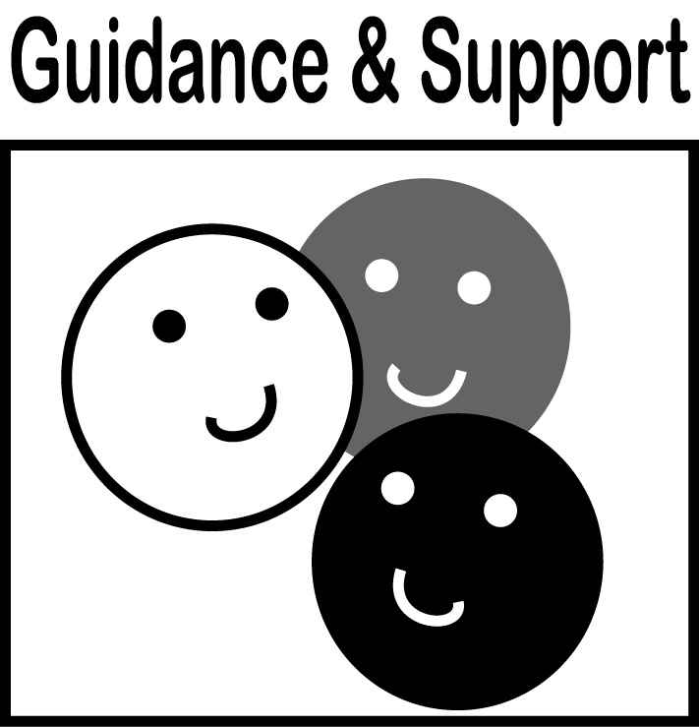  Level of guidance and support from adults before writing:  Check off what was done before the student wrote the piece being scored.  - Discussion  - Read aloud or shared reading  - Drawing  - Vocabulary word bank  - Shared or interactive writing  - Graphic organizer  - Language frames
3  Meets | NARRATIVE WRITING (W3)  - Engages and orients the reader by establishing a context and introducing a narrator and/or characters (W3a)  - Organizes event sequence that unfolds naturally and logically (W3a)  - Uses narrative techniques, such as dialogue, pacing, and description to develop experiences, events, and/or characters (W3b)  - Uses a variety of transition words, phrases, and clauses to convey sequence and signal shifts from one time frame to another (W3c)  - Uses precise words and phrases, relevant descriptive details, and sensory language to convey experiences and events (W3d)  - Provides a conclusion that follows from the narrated experiences or events (W3e)  WRITING PROCESS (W4-W8)  - Uses clear/coherent writing where development, organization and style are appropriate to task, purpose, and audience (W4)  - WGASFA* Develops and strengthens writing by planning, revising, and editing, rewriting, or tying a new approach (W5)  - Uses technology to produce writing (W6)  - Uses keyboarding skills to minimum of 3 pages in a single sitting (W6)  - Conducts research drawing on several resources (W7)  - Assesses credibility of sources; quotes or paraphrases the data and conclusions (W8)  - Avoids plagiarism and provides basic bibliographic information (W8) |  |  | Adequate use of correct sentence formation, punctuation, capitalization, grammar usage and spelling for grade level, for example:  - Uses a variety of pronouns effectively (L1a-d)  - Uses a variation of simple, compound, complex, and compound-complex sentences for meaning and interest (L3a)  - Ensures that verbs agree with compound subjects  - Uses commas when linking two clauses with a conjunction in compound sentences  - Uses correct capitalization  - Spells correctly (L2b)
2  Almost Meets | - Uneven development of setting, characters, and plot  - Events are unevenly developed  - Some use of precise words and phrases, relevant descriptive details, and sensory language to convey experiences and events  - May not write multi-paragraphs  - Planning for writing is limited  - Uses some linking words and phrases |  |  | Limited use of correct sentence formation, punctuation, capitalization, grammar usage and spelling for grade level, for example:  - Contains some run-on sentences  - Uses mostly simple or compound sentences  - Uses propositional phrases, appositives, dependent and independent clauses, transitions or conjunctions incorrectly  - Contains some punctuation errors  - Contains some capitalization and/or spelling errors
1  Does Not Meet | - Has little or no plot, may be just a series of events  - Provides few details or descriptions  - Uses no or few transitions  - Does not write multiple paragraphs  - Planning for writing is absent or disorganized |  |  | Infrequent use of correct sentence formation, punctuation, capitalization, grammar usage and spelling for grade level, for example:  - Contains many run-on sentences  - Contains many punctuation errors  - Contains many capitalization and/or spelling errors
- WGASFA: “with guidance and support from adults”
This rubric was adapted from rubrics at sbusd.org and information from Smarter Balanced Assessments (www.smarterbalanced.org) using the California Common Core Standards at www.cde.ca.gov.

Student Version
Grade | 6 | Title/Subject | Student Rubric
Student Prompt:
Choose one of the pictures to write a story about. Look carefully at the pictures and then think of an idea for a story that could be told about what is going on in the pictures. Write a story to go with the picture which includes all of the things you’ve learned about narrative writing.
Writing Tips:
- Make a title for your story.
- Introduce the reader to the situation and characters in the story with clear details.
- Use dialogue, pacing, and description to develop the story and show the responses of the characters to the events.
- Use a variety of transition words, phrases and clauses to manage the sequence of the story, making sure it unfolds naturally.
- Use concrete words and phrases and sensory details to help the reader truly experience what is going on in the story.
- Write an ending that flows from the story.
Step 1: Plan
- Plan your characters, plot, and setting before you begin to write.
Step 2: Draft
- Write your draft.
- Read your draft to a partner and make notes about what you want to change.
Step 3: Reread and Revise
- Does it make sense?
- Does it have enough interest, detail?
- Are the time sequences and transitions clear?
Step 4: Edit
  - Capitals at the beginning of sentences and for proper nouns
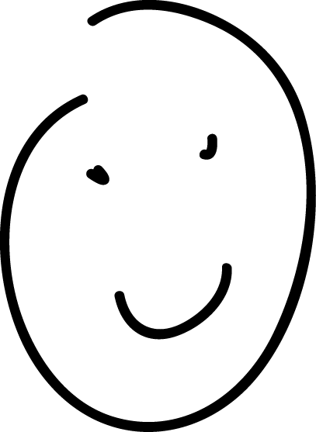

  - Punctuation: (end points) . ! ?
Good work!
Commas , quotation marks “ ”
  - Spelling
  - Complete sentences
  - Check for fragments and run-ons and check verb tense and noun-verb agreement.
Step 5: Final Draft
- Recopy and fix your mistakes.

Student Version
Grade | 6 | Title/Subject | Student Prompt-1

Add your pictures here.

Student Version
Grade | 6 | Title/Subject | Student Prompt-2

Student Version
Grade | 6 | Title/Subject | Student Prompt-3

Student Version
Grade | 6 | Title/Subject | Student Prompt-4

