This is a sample generic argument writing performance task. Simply modify the highlighted text and add your articles or videos.

Teacher Version
Grade | 7 | Title/Subject | Type your title here
The following sections are included in this Teacher Version:
- Process: Day 1, 2 and 3
- Teacher Directions for Scoring Rubric
- Student Instructions and Articles

Overview

On Day 1 students will engage in a shared reading and note-taking activity using three argument/opinion texts. On Day 2, after the group activity, they will be directed to plan, and begin to draft an argument writing piece utilizing the information they read in the texts as well as notes they took during the shared lesson. On Day 3 students will finish their drafts, revise and edit their writing, and if they choose, produce a final copy.

Process

DAY 1: Shared Reading and Note-taking: Up to 60 minutes
Step 1: Connect to Background Knowledge
Provide an introduction to the classroom activity by indicating that after this activity, students will be writing an argument writing piece. Ask students to discuss this orally. Possible questions could include:
“Do you think ____________________? What are the advantages of ____________________? What are the disadvantages? Would you rather have h____________________?”
For active engagement encourage pair or group sharing, before sharing out with whole group. You may also want to use the “take a stand” activity from our training handbook to generate discussion.
Step 2: Accessing the Information
- Explain: “Now we will read the pros and cons of ____________________. You will be writing an argument paper to your teacher about whether you agree or disagree with the topic and you will include information from the articles provided in your reasons.” Use the information from the texts to supply your reasons. Read the articles with the students and point out facts and features (pictures, captions, etc.) Use ONLY the sources provided in this prompt packet.
- Lead a whole class discussion about the sources.
- Think-Pair-Share: “Tell your partner what you learned about the topic.” Make sure both partners have time to share with each other.

DAY 2: Planning and Writing a Draft: Up to 60 minutes
Step 3: Clarify Expectations for the Writing Task:
Explain: “In a few minutes you will have a chance to look at the sources, plan, and write a draft to explain to me about the topic and your argument. Tomorrow you will have a chance to change and edit your work from today or add more detail.”
Review the student directions and checklist for the writing assignment and give each student a sheet of blank paper for planning and lined paper for writing.
Step 4: Clarify Expectations for the Writing Task:
Tell students to begin planning their writing on the blank sheet of paper. You can remind them of planning strategies you have taught in your classroom such as outlining, lists, or webs. Don’t provide a plan yourself just remind them of the strategies for planning.
After 10 minutes suggest to students that they begin writing their drafts.
Collect all materials from Day 2.
DAY 3: Up to 60 minutes
- Allow students to access the sources, their notes, the classroom activity charts/key word lists, and their draft.
- Direct students to re-read their draft from Day 2. Review the task using the student checklist poster.
- When students are finished writing, remind them to reread and edit.
- Students may create a final draft or use word processing to publish their writing if time allows.
- Collect all student writing materials.

Teacher Directions for Scoring Rubric:
Use the argument writing rubric to score the writing and enter a score for each student into assessment log.

Grade | 7 | Argument Writing Rubric

Level | ARGUMENT WRITING/PROCESS | LANGUAGE CONVENTIONS | WITH GUIDANCE and SUPPORT  FROM ADULTS
4  Exceeds | - Meets all expectations in level 3  - Acknowledges and distinguishes claims from alternate/opposing claims  - Maintains a formal style and objective tone in argument  - Document is very well presented and documented with excellent organization | Mostly correct use of language conventions, and some above grade level skills used, for example:  - Meets all expectations in level 3  - Uses verbs in indicative, imperative, interrogative, conditional, and subjunctive mood  - Uses verbs in active/passive voice and in conditional/subjunctive mood to achieve particular effects |   Level of guidance and support from adults before writing:  Check off what was done before the student wrote the piece being scored.  - Discussion  - Read aloud or shared reading  - Drawing  - Vocabulary word bank  - Shared or interactive writing  - Graphic organizer  - Language frames
3  Meets | ARGUMENTATIVE WRITING (W1)  - Introduces claim(s) and acknowledges/addresses alternate or opposing claims (W1a)  - Organizes reasons and evidence logically (W1a)  - Supports claims/counterarguments with logical reasoning and relevant evidence demonstrating understanding of topic/text (W1b)  - Uses words, phrases, and clauses to create cohesion and clarify relationships among claims, reasons and evidence (W1c)  - Establishes and maintains a formal style (W1d)  - Provides a concluding statement or section that follows from and supports the argument presented (W1e)  WRITING PROCESS (W4-W8)  - Writes clearly and coherently and organization and style are appropriate to task, purpose and audience (W4)  - WGASFA* Develops and strengthens writing as needed, by planning, revising, editing, rewriting, or trying a new approach, focusing on how well purpose and audience have been addressed (W5)  - Uses technology to produce writing and link to and cite sources (W6)  - Assesses credibility of each source and quotes/paraphrases the data/conclusions of each source (W8)  - Avoids plagiarism and follows a standard format for citation (W8) | Adequate use of correct sentence formation, punctuation, capitalization, grammar usage and spelling for grade level, for example:  - Chooses among simple, compound, complex, and compound-complex sentences to signal differing relationships between ideas (L3b)  - Places phrases and clauses within a sentence, recognizing and correcting misplaced or dangling modifiers (L1b)  - Uses a comma to separate coordinate adjectives (L2a)  - Spells correctly (L2b)  - Chooses language that expresses ideas precisely and concisely (L3a)  - Eliminates wordiness and redundancy (L3a)
2  Almost Meets | - Claim is well stated but does not address opposing/alternate claims  - Has some reasons and evidence but may not be logical or relevant  - Does not establish or maintain a formal style  - Concluding statement may be unclear or not well supported  - Writing may not fully address audience, task, or purpose | Limited use of correct sentence formation, punctuation, capitalization, grammar usage and spelling for grade level, for example:  - Contains some run-on sentences  - Uses mostly simple or compound sentences  - Language may not always be precise or appropriate  - Contains some punctuation errors  - Contains some capitalization errors  - Contains some spelling errors
1  Does Not Meet | - Limited information on topic  - Does not state an argument or claim  - Includes little to no facts or focus  - Information is disorganized or missing | Infrequent use of correct sentence formation, punctuation, capitalization, grammar usage and spelling for grade level, for example:  - Contains many run-on sentences  - Contains many punctuation errors  - Contains many capitalization errors  - Contains many spelling errors
- WGASFA: “with guidance and support from adults”
This rubric was adapted from rubrics at sbusd.org and information from Smarter Balanced Assessments (www.smarterbalanced.org) using the California Common Core Standards at www.cde.ca.gov.

Student Version
Grade | 7 | Title/Subject | Type your title here


Student Prompt:
Choose a position on the argument. Write a multi-paragraph essay to your teacher explaining your argument. Include information from the following articles as you write.

Writing Tips:
- Be sure to introduce your claim and group related facts together.
- Use evidence from the two sources to develop your argument.
- Include linking words and phrases to connect your ideas, create cohesion, and clarify relationships among claims, reasons, and evidence.
- Maintain a formal style throughout.
- End with a conclusion.

Reminders:
- You can look at the two sources and your key word list to help you with your writing.
- You might begin by making a plan or drawing a graphic organizer to help you with your thinking.
- Do not plagiarize; do not copy sentences from the sources.

Step 1: Plan
Plan: review the texts and your notes
- Make a plan on the blank paper for your writing.

Step 2: Draft
- Introduce your claim or argument.
- Address opposing claims or arguments.
- Include relevant evidence to support your claim.
- Support your claims with logical reasoning.
- Group information together as you write into paragraphs.
- Write a concluding paragraph or section.
- Write a bibliography of sources for your paper using a standard format for citation.

Student Version
Grade | 7 | Title/Subject | Type your title here

Step 3: Reread and Revise
- Does it make sense?
- Have you used evidence from the texts to support your claim?
- Have you used linking words to organize your writing?
- Have you used a variety of simple, compound, and complex sentences to signal relationships between ideas?
- Have you maintained a formal style?
- Checked for wordiness and redundancy?
- Is it right for your task, purpose and audience?

Step 4: Edit
Reread your writing and revise:
  - Capitals
  - Punctuation: (end points) . ! ?
  - Commas , quotation marks “ ” underlining and italics
  - Spelling
  - Complete sentences; avoid run-ons and fragments.
  - Precise and concise language to express your ideas

Step 5: Final Draft
- Recopy and fix your mistakes.


Good work!
Writing an Argument Poster
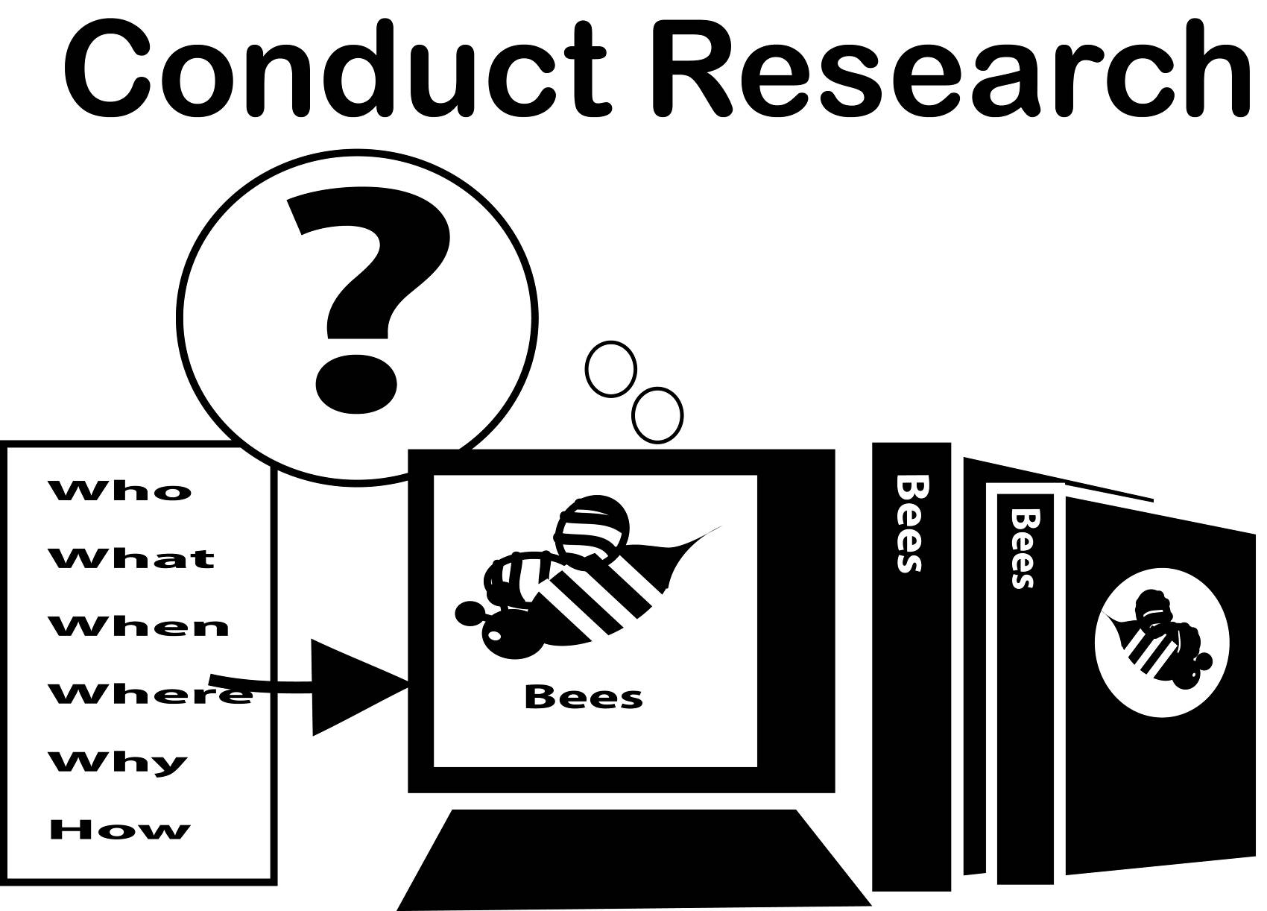
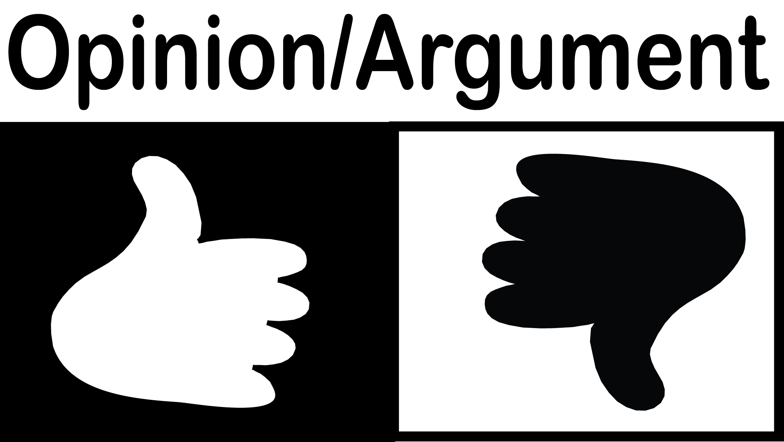


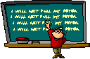
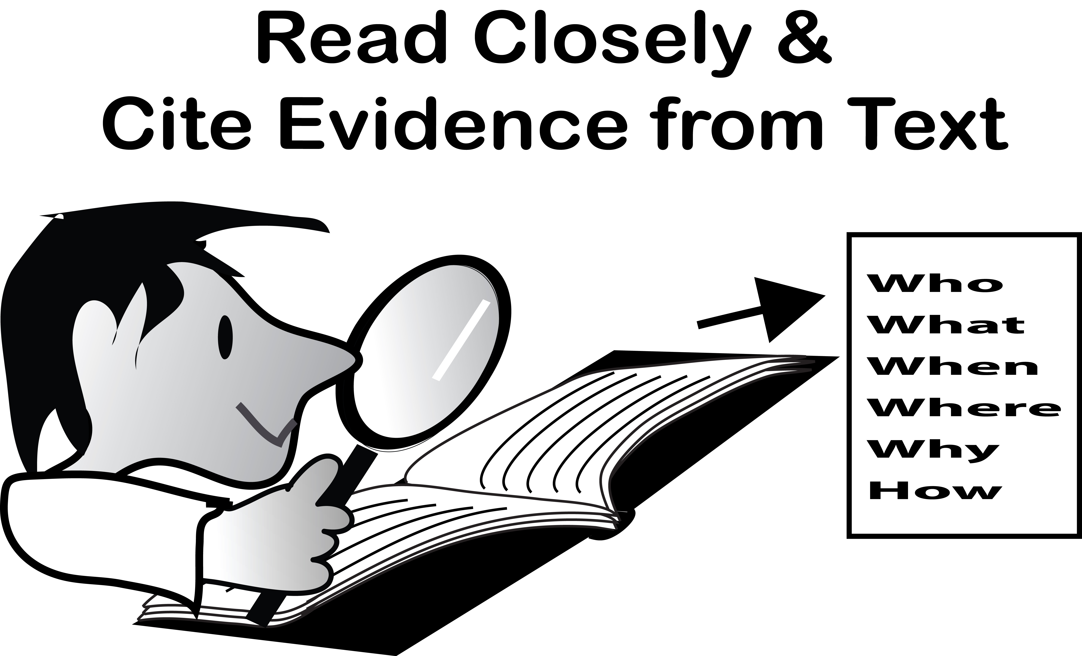


☑
- Research a topic.
- State your claim: choose an argument which is well supported with evidence.
- List evidence you will use. Focus on the most credible sources.
- Choose your best evidence
- Write a topic sentence that states your claim
- Write paragraphs outlining your argument with evidence.
- Use linking words to connect your ideas
- Write a conclusion to remind the reader of your claim and/or call for action
- Reread and revise: Does it make sense? Sound convincing? Any missing information?
- Reread and edit: Check
    - capitals
    - spelling
    - punctuation
- Type or write a final draft!
- Celebrate your hard work!

Student Reading Text
Grade | 7 | Title/Subject | Type your title here
Add your articles here.

