
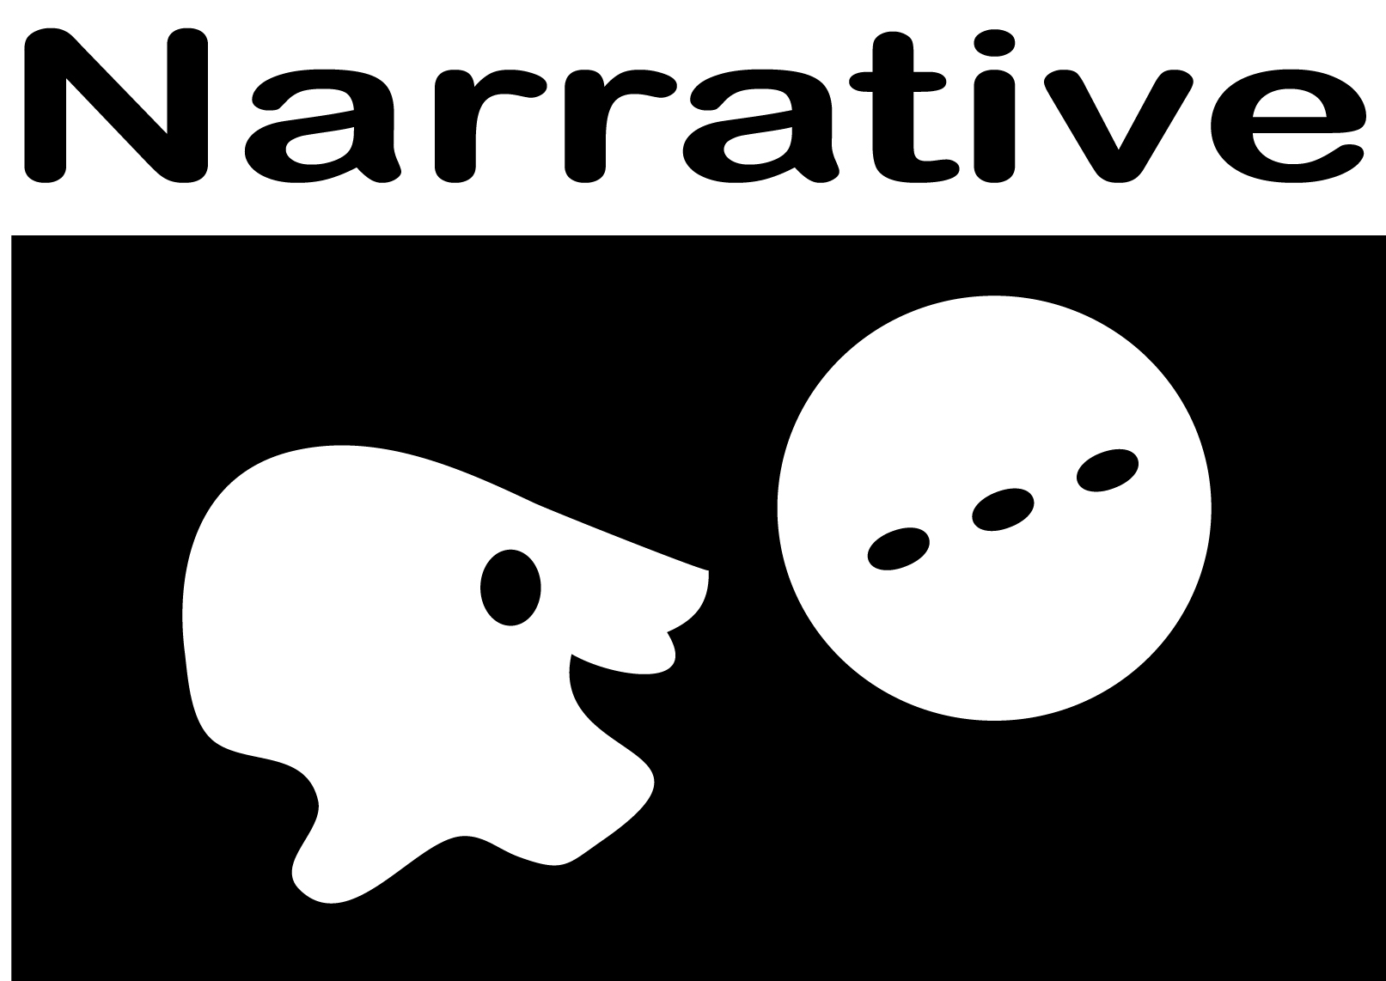

Grade 8 Narrative Writing
Level 3 Rubric Requirements

- Paper develops real or imagined experiences or events (W3)
- Uses effective techniques, relevant descriptive details, and well-structured event sequence (W3b)
- Establishes a context introducing a narrator and or characters (W3a)
- Event sequence unfolds naturally and logically (W3a)
- Uses dialogue, pacing, and description to develop experiences, events, and/or characters (W3b)
- Uses a variety of transition words, phrases and clauses to convey sequence and signal shifts from one time frame or setting to another and show relationships among experiences and events (W3c)
- Uses precise words and phrases, relevant descriptive details, and sensory language to convey experiences and events (W3d)
- Provides a conclusion that follows from the narrated experiences or events (W3e)
__________________________________________
- Writing is appropriate to task, purpose, and audience (W4)
- Develops and strengthens writing by planning, revising, and editing or trying a new approach and focusing on how well purpose and audience have been addressed (W5)
- Editing demonstrates command of English language: corrects capitalization, spelling, and punctuation (W5)
- Uses time for reflection, and revision (W10)

