Generic Version: Just add your favorite pictures and change highlighted text to indicate your subject.

Teacher Version
Grade | K | Title/Subject | Recent Event
The following sections are included in this Teacher Version:
- Process: Day 1, 2 and 3
- Teacher Directions for Scoring Rubric and pictures for prompts
- Student Prompt and Instructions

Overview

Students will describe an event. (Examples: played with a friend, played with a pet, had a birthday, etc.) They will then write a story about that event. On day 1 they will choose an event to talk about. On Day 2, they will they will be directed to plan, and begin to draft a narrative writing piece about this event. On Day 3 they will write the story to go with their plan.

Process

DAY 1: Shared Reading and Note-taking: Up to 40 minutes
Step 1: Connect to Background Knowledge
Provide an introduction to the classroom activity by indicating that after this activity, students will be writing a narrative story about an event that recently happened.
Brainstorm a list of all the events might have happened recently. (Examples: played with a friend, played with a pet, had a birthday, etc.) Have students choose one of the events to write about in their narrative.
Ask students to share their stories orally. Possible questions could include:
“Did you like this activity? What did you play with? What did you do?
For active engagement encourage pair or group sharing, before sharing out with whole group.
Step 2: Creating Context
- Demonstrate a brief story of your own, such as what you had for breakfast and how you liked it, etc.
- Think-Pair-Share: “Now, tell your partner about your event.” Make sure both partners have time to share with each other.

DAY 2: Planning and Writing a Draft: Up to 40 minutes
Step 3: Explain the Writing Task:
Explain: “In a few minutes you will have a chance to plan, draw and write a draft to tell me about your event. Tomorrow you will have a chance to change and edit your work from today or add more detail.”
Review the student directions and checklist for the writing assignment and give each student a sheet of blank paper for planning and lined paper for writing.
Step 4: Clarify Expectations for the Writing Task:
Tell students to begin planning their writing on the blank sheet of paper. You can remind them of planning strategies you have taught in your classroom such as outlining, lists, webs, or drawing. Don’t provide a plan yourself just remind them of strategies for planning.
After 10 minutes suggest to students that they begin writing their drafts.
Collect all materials from Day 2.
DAY 3: Up to 40 minutes
- Allow students to access their plans and drawings.
- Direct students to re-read their draft from Day 2. Review the task using the student checklist poster. Suggest to students to add details and information to their narrative story.
- When students are finished writing, remind them to reread and check for capitals and periods.
- Collect all student writing materials.

Teacher Directions for Scoring Rubric:
Use the narrative writing rubric to score the writing and enter a score for each student into assessment log.

Developmental Writing Checklist
Student Name
Level | Stage |  | Description | Sample
0 | Pictorial |  | - Draws picture
1 | Pictorial with Imitated Writing |  | - Orally tells about pictures (teacher writes message)  - Draws pictures  - Imitates writing | The flower is growing.
RUBRIC 1
2 | Random Letters |  | Writing Content  - Writes some letters fluently/symbols fluently to represent a message  - Uses ABC chart as a resource  - Little or no concept of space between words  - Attempts to read/retell what has been written or drawn  - Writes to convey a message  - Writes one or more thoughts  Writing Conventions  - May use one letter to write a word (spellings are telegraphic, usually representing salient initial and/or final sounds  - Prints own name or a known word  - Usually writes left to right and knows where to begin writing (may reverse some letters)  - Writes mostly capital letters  - Writes some letters with correct formation  - Uses letter-like forms and/or random letter strings | I like my dog.
RUBRIC 2
3 | Random Letters with some Sound/Symbol Match |  | Writing Content  - Writes some letters fluently/symbols fluently to represent a message  - Uses ABC chart as a resource  - Attempts to read/retell what has been written or drawn  - Writes to the topic  - Writes one or more thoughts  Writing Conventions  - Prints own name or a known word  - Writes left to right (may reverse some letters)  - Uses spaces between words some of the time (between 1-2 words)  - Correctly uses some letters to match sounds with some random letters  - Starts to use the beginning and ending sounds with some random letters | I found a jewelry box.
RUBRIC 3
Developmental Writing Checklist
Level | Stage | Description | Sample
4 | Partially Alphabetic | Writing Content  - Writes more letters fluently to represent a message  - Attempts to read/retell what has been written or drawn  - Writes to the topic  - Writes one or more thoughts  Writing Conventions  - Writes consonants is sequential order and represents some vowels (vowels are often not the correct ones)  - Uses spaces between words most of the time (no spaces between 1-2 words)  - Correctly spells some (3-4) high frequency words | I found a lamp and a genie came out.
RUBRIC 4 | Partially Alphabetic
5 | Fully Alphabetic | Writing Content  - Identifies an error by circling or crossing out; may not correct  - Rereads what has been written while composing  - Writes to the topic/text type: informative, Opinion, Narrative  - Writes two or more thoughts in a logical sequence  - Most sentences are complete (this does not include punctuation)  Writing Conventions  - Represents beginning and ending consonants in sequential order and includes a vowel in most words (may not be correct)  - Correctly spells more (5-10) high-frequency words  - Uses spaces between words consistently  - Begins to use end punctuation (punctuation may be incorrect when text contains more than one sentence)  - Uses some beginning capitalization | Once upon a time there was (were) four butterflies. They went on an adventure in the woods.
RUBRIC 4 | Fully Alphabetic
6 | Early | Writing Content  - Identifies an error by circling or crossing out and corrects it  - Rereads what has been written  - Writes to the topic /text type: Informative, Opinion, Narrative  - Writes three or more thoughts in a logical sequence  - Most sentences are complete (this does not include punctuation)  - Provides a sense of closure  Language Use and Conventions  - Includes a vowel in most syllables (may not be correct)  - Correctly spells more (6-10) high-frequency words  - Uses end punctuation correctly most of the time  - Uses some beginning capitalization | My favrit book is clifford. He is a funi dog  Hes so big nd red ! do you like clifrd?
RUBRIC 4 | Early

Kindergarten Developmental Writing Checklist

Beginning of Year | End of Trimester 1 | End of Trimester 2 | End of Trimester 3
Date: | Date: | Date: | Date:
Writing Level: | Writing Level: | Writing Level: | Writing Level:
Comments: | Comments: | Comments: | Comments:
- Students can be considered at a level if they have 90% of the items under control at that level.
- Teachers may want to consider starting guided reading with those students who are at Level 4 on this checklist.
- Bold = Gentry developmental stages

Grade |  | K | Narrative Writing Rubric - Kindergarten
Level | NARRATIVE WRITING |  |  | LANGUAGE CONVENTIONS | WITH GUIDANCE and SUPPORT  FROM ADULTS
4  Exceeds | - Meets all expectations in level 3  - Uses some descriptive words  - Writes multiple complete sentences  - Provides a sense of closure to story/event |  |  | Mostly correct use of language conventions, and some above grade level skills used, for example:  - Meets all expectations in level 3  - Writes proper names with capital letters  - Consistently spells grade level appropriate words correctly  - Spells most kinder sight words correctly | 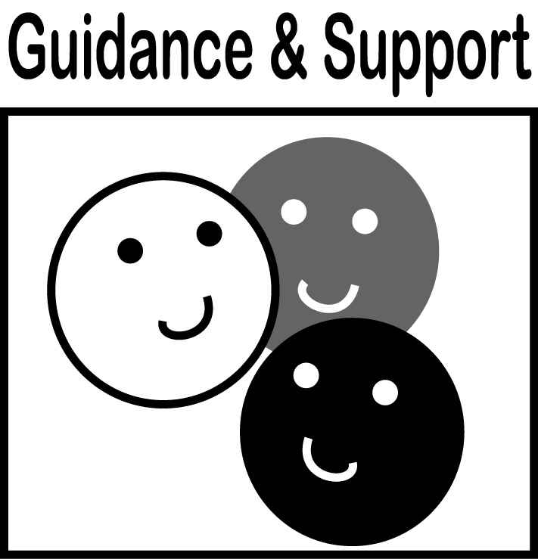  Level of guidance and support from adults before writing:  Check off what was done before the student wrote the piece being scored.  - Discussion  - Read aloud or shared reading  - Drawing  - Vocabulary word bank  - Shared or interactive writing  - Graphic organizer  - Language frames
3  Meets | NARRATIVE WRITING (W3)  - Draws, dictates, and/or writes to narrate a single event or several loosely linked events (W3)  - Tells about the events in the order in which they occurred (W3)  - Provides a reaction to what happened (W3)  WRITING PROCESS (W5-W8)  - WGASFA* Adds details to strengthen writing (W5)  - WGASFA* Explores digital tools to write (W6)  - Participates in shared research projects (W7)  - WGASFA* Recalls information from experiences or gathers information from provided sources (W8) |  |  | Adequate use of correct sentence formation, punctuation, capitalization, grammar usage and spelling for grade level, for example:  - Writes left to right and return sweeps (L1a)  - Uses spaces between words most of the time (L1c)  - Prints many upper- and lowercase letters (L1a)  - Capitalizes the first word in a sentence and the pronoun I (L2a)  - Recognizes and names end punctuation (L2b)  - Writes a letter or letters for most consonant and short-vowel sounds (L2c)  - Spells simple words phonetically (L2d)  - Spells some kinder sight words correctly
2  Almost Meets | - Draws about event  - Starts narrative but provides little information  - Includes a simple sentence (s) about event  - May rely on copying from a patterned sentence—writing sounds like a “list” |  |  | Limited use of correct sentence formation, punctuation, capitalization, grammar usage and spelling for grade level, for example:  - Begins to write from left to right and return sweeps  - Begins to space words correctly  - Writes uppercase letters are random or within words  - Uses only uppercase letters in writing  - Uses no or few end punctuation marks  - Spells some words phonetically
1  Does Not Meet | - Makes few or no attempts to write about event  - May label drawing or list objects or ideas  - Dictates ideas for narrative, but unable to write without copying |  |  | Infrequent use of correct sentence formation, punctuation, capitalization, grammar usage and spelling for grade level, for example:  - Uses random letters to represent print  - Makes no attempts at correct spelling  - Writes no complete sentences  - Writes in all directions or may just label drawing
- WGASFA: “with guidance and support from adults”
This rubric was adapted from rubrics at sbusd.org and information from Smarter Balanced Assessments (www.smarterbalanced.org) using the California Common Core Standards at www.cde.ca.gov.


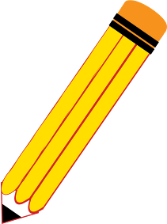
Student Version
Grade | K | Title/Subject | Recent Event
Tell me about your event.
Now write your story.

- Write your name on your paper.
- Tell me about what happened
and tell me if you had fun.
- Draw a picture of what you are writing about.

Be sure to
  - Use a CAPITAL at the beginning of your sentences and for the pronoun “I”.
  - Use an end point at the end of your sentences ➔ . ! ?
  - Try to spell the words you know correctly.
  - If you see a mistake, fix it!
- Make sure to leave spaces between your words.


- Use your neatest handwriting.
Good work!

