This is a sample generic opinion writing performance task. Simply modify the highlighted text and add your articles or videos.

Teacher Version
Grade | K | Title/Subject | Type your title here
The following sections are included in this Teacher Version:
- Process: Day 1, 2 and 3
- Pictures of Choices
- Teacher Directions for Scoring Rubric
- Student Instructions and Articles
Overview

On Day 1 students will engage in watching videos, shared reading and note-taking activities about two possible choices on a topic. On Day 2, after the group activity, they will be directed to plan, and begin to draft an opinion writing piece about which choice they think they would make utilizing the information they read in the texts as well as notes they took during the shared lesson. On Day 3 students will finish their drafts, revise and edit their writing, and if they choose, produce a final copy.

Process

DAY 1: Shared Reading and Note-taking: Up to 40 minutes
Step 1: Connect to Background Knowledge
Provide an introduction to the classroom activity by indicating that after this activity, students will be writing an opinion piece focused on the topic and what they like or don’t like. Ask students to share their opinions orally. Show the pictures of the choices in the topic and ask:
“Would you like to have one of these ____________? Which one do you think would be best? Why do you like it so much? Why don’t you like the others?
For active engagement encourage pair or group sharing, before sharing out with whole group.
Step 2: Accessing the Information
- Explain: “Now we will learn about this.” Show the videos and read each source, pointing out important facts and features (pictures, captions, etc.) Use ONLY the sources provided in this prompt packet.
- Lead a whole class discussion about the sources. You may draw a pictorial of each pet next to the text and make a word bank or label the drawing.
- Choose: Post the images and text about each choice around the room and have the students move to the image they choose. Encourage students to talk about why they chose that in their small groups.

Have the class watch one or more videos on the topic.
Put your links here

DAY 2: Planning and Writing a Draft: Up to 40 minutes
Clarify Expectations for the Writing Task:
Explain: “Now you will have a chance to look at the sources, and plan your writing to explain to me why you like or don’t like the topic (or book). In your writing, tell me which one you like best and why.
Review the student directions and checklist for the writing assignment and give each student a sheet of blank paper for planning.
Tell students to begin planning their writing on the blank sheet of paper. You can remind them of planning strategies you have taught in your classroom such as outlining, lists, webs, or drawing. Don’t provide a plan yourself just remind them of strategies for planning.
After about 10 minutes, pass out lined paper to students and tell them to begin their opinion writing piece. Students may take another 30 minutes to write about their choice or opinion and why they think it is best.
Collect all materials from Day 2.
DAY 3: Up to 40 minutes
- Allow students to access the sources, their notes, the classroom activity charts/key word lists, and their draft.
- Direct students to re-read their draft from Day 2. Review the task using the student checklist poster. Suggest to students to add reasons and information to their opinion statement.
- When students are finished writing, remind them to reread and check for capitals and periods.
- Collect all student writing materials.

Teacher Directions for Scoring Rubric:
Use the opinion writing rubric to score the writing and enter a score for each student into assessment log.

Put your pictures of choices here.
One to a page.

Grade |  | K |  | Opinion Writing Rubric
Level | OPINION WRITING |  |  |  | LANGUAGE CONVENTIONS | WITH GUIDANCE and SUPPORT  FROM ADULTS
4  Exceeds | - Meets all expectations in level 3  - Includes a reason for opinion  - Uses some descriptive words  - Writes multiple complete sentences |  |  |  | Mostly correct use of language conventions, and some above grade level skills used, for example:  - Meets all expectations in level 3  - Writes proper names with capital letters  - Consistently spells grade level appropriate words correctly |   Level of guidance and support from adults before writing:  Check off what was done before the student wrote the piece being scored.  - Discussion  - Read aloud or shared reading  - Drawing  - Vocabulary word bank  - Shared or interactive writing  - Graphic organizer  - Language frames
3  Meets | OPINION WRITING (W1)  - Draws, dictates, and/or writes an opinion about a topic or book (W1)  - Names the book or topic (W1)  WRITING PROCESS (W5-W8)  - WGASFA* Adds details to strengthen writing (W5)  - WGASFA* Explores digital tools to write (W6)  - Participates in shared research projects (W7)  - WGASFA* Recalls information from experiences or gathers information from provided sources (W8) |  |  |  | Adequate use of correct sentence formation, punctuation, capitalization, grammar usage and spelling for grade level, for example:  - Writes left to right and return sweeps (L1a)  - Uses spaces between words most of the time (L1c)  - Prints many upper- and lowercase letters (L1a)  - Capitalizes the first word in a sentence and the pronoun I (L2a)  - Recognizes and names end punctuation (L2b)  - Writes a letter or letters for most consonant and short-vowel sounds (L2c)  - Spells simple words phonetically (L2d)
2  Almost Meets | - Draws about topic  - Names topic or book but gives no opinion  - Includes simple sentences about topic  - May rely on copying from a patterned sentence |  |  |  | Limited use of correct sentence formation, punctuation, capitalization, grammar usage and spelling for grade level, for example:  - Begins to write from left to right and return sweeps  - Begins to space words correctly  - Writes uppercase letters are random or within words  - Uses only uppercase letters in writing  - Uses no or few end punctuation marks  - Spells some words phonetically
1  Does Not Meet | - Makes few or no attempts to write  - Provides no details  - Uses no or incorrect spacing between words |  |  |  | Infrequent use of correct sentence formation, punctuation, capitalization, grammar usage and spelling for grade level, for example:  - Uses random letters to represent print  - Makes no attempts at correct spelling  - Writes no complete sentences  - Writes in all directions or may just label drawing

- WGASFA: “with guidance and support from adults”
This rubric was adapted from rubrics at sbusd.org and information from Smarter Balanced Assessments (www.smarterbalanced.org) using the California Common Core Standards at www.cde.ca.gov.

Student Version
Grade | K | Title/Subject | Type your title here

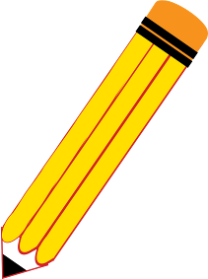
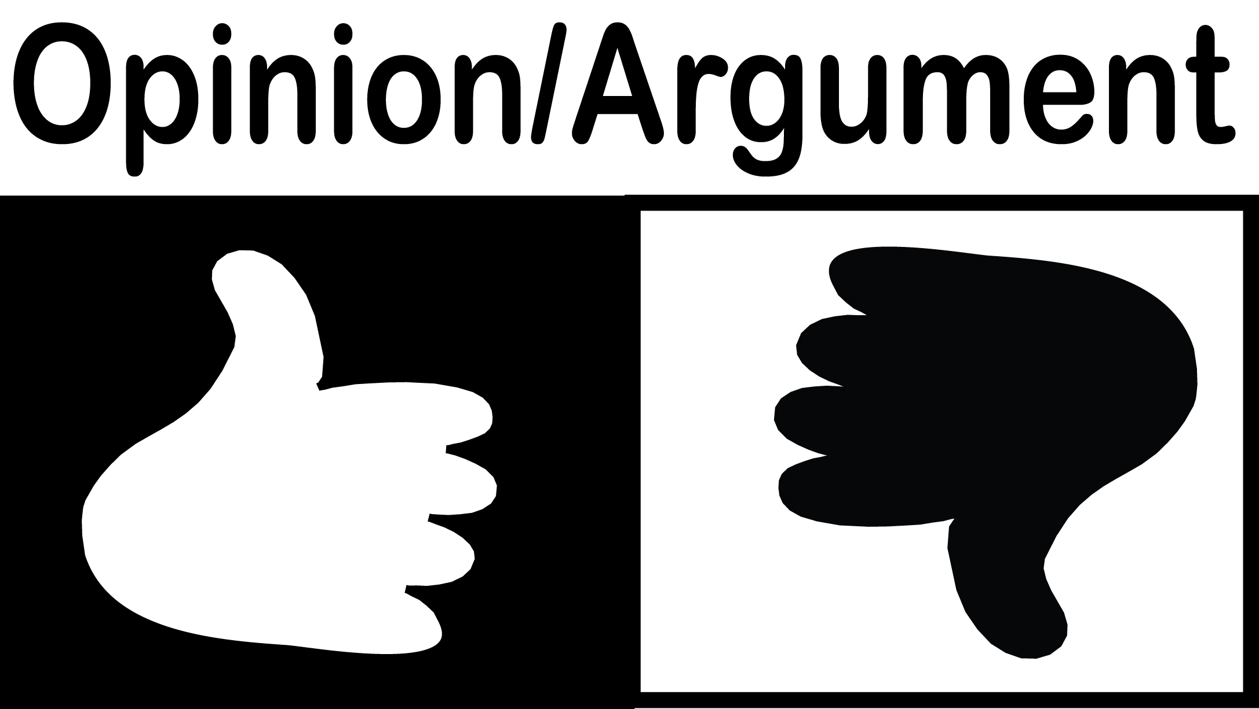

Talk about this topic with your class.
Now tell me which you like best and why.

Write about which you like best.

- Write your name on your paper.

- Tell me which you like best.

- Tell me why you like it so much.

- Draw a picture of your choice.

Be sure to
  - Use a CAPITAL at the beginning of your sentences.
  - Use an end point at the end of your sentences ➔ . ! ?
  - Try to spell the words you know correctly.
  - Use complete sentences.
  - If you see a mistake, fix it!
- Make sure to leave spaces between your words.
- Use your neatest handwriting.



Good work!

Student Reading Text
Grade | K | Title/Subject | Type your title here

Add your articles here.

