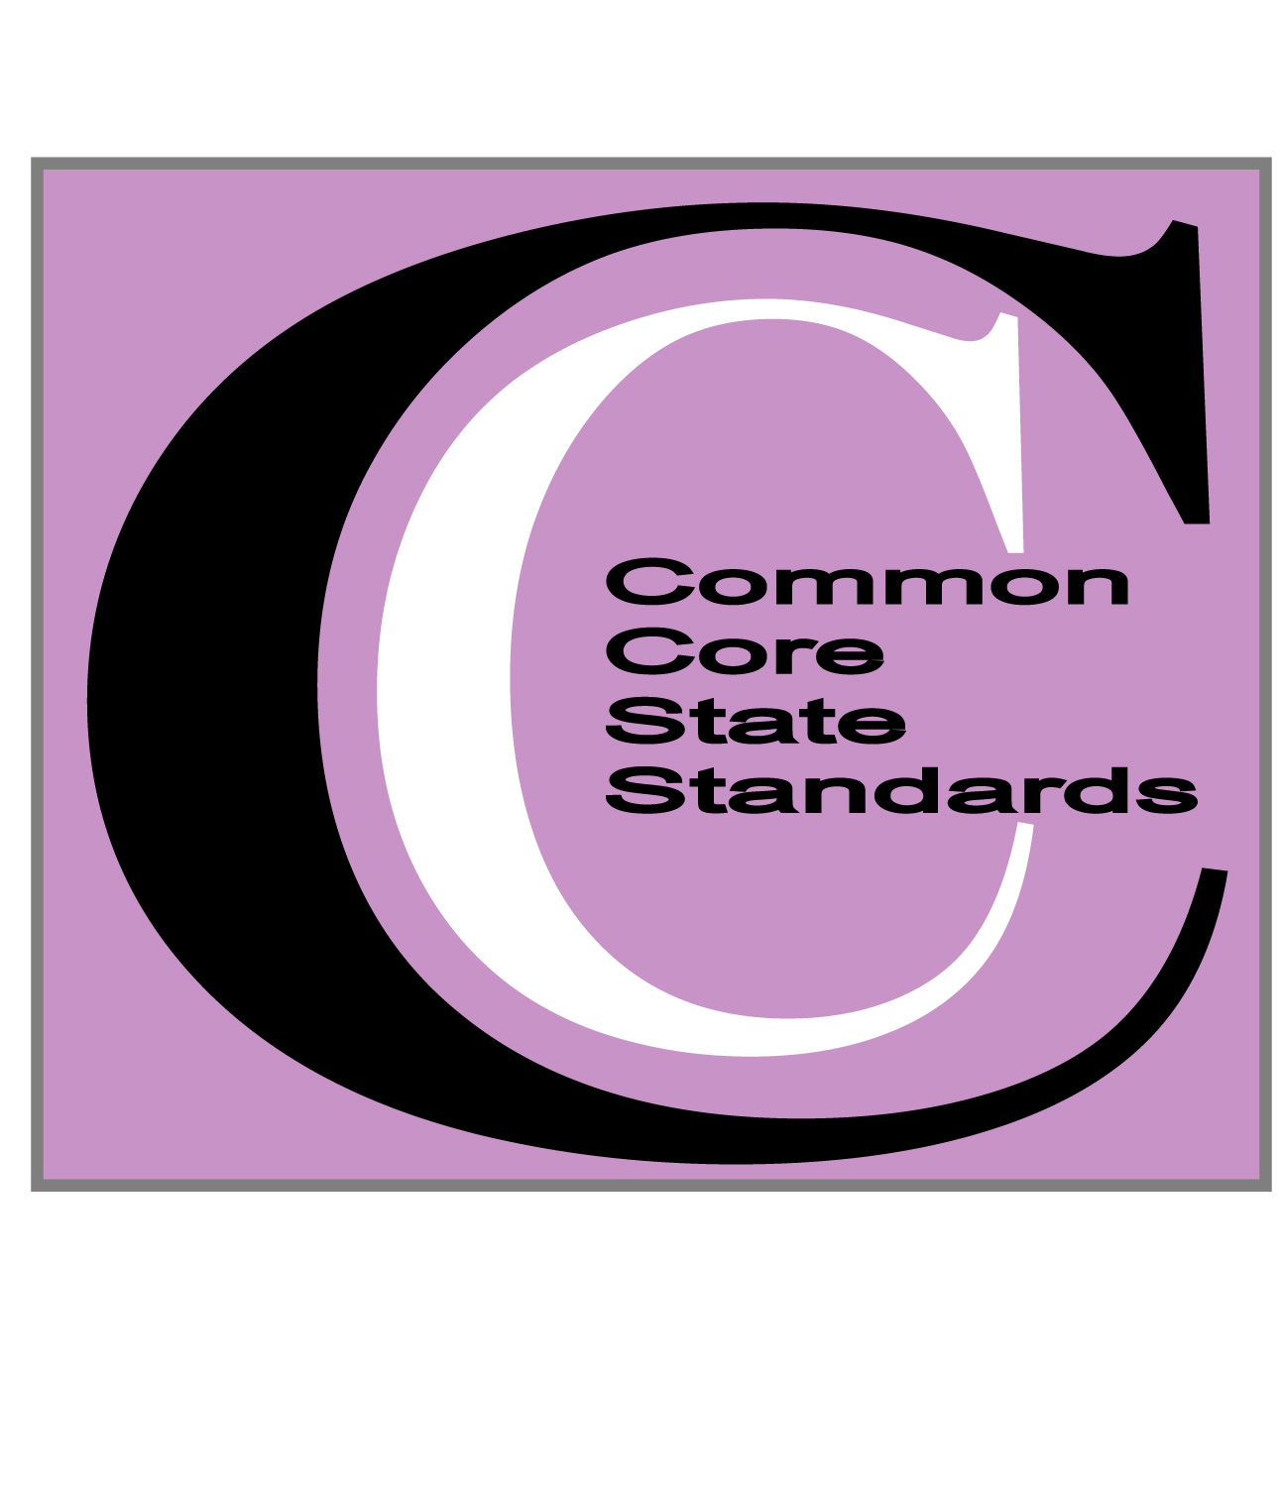
Common Core Standards-based Developmental Writing Portfolios

Gathering and analyzing progress with writing over time through the use of a portfolio is a time-honored tradition in the teaching of writing. We've created this CCSS document in order for you to do just that. Here's how to use the forms:
- Duplicate either one or both forms as indicated by the grade level you teach and the range of writers in your classroom. For example, if you teach third grade, but have students writing from a first to a fourth grade writing level, you will need both forms. If you teach first and range from K-leveled to 2nd grade leveled writers, the K-2 form will suffice.
- Glue these forms to the outside of a file folder.
- Periodically gather a writing sample from your students. You'll want to attach one of our writing rubrics to show what performance level that sample illustrates for that student as well as indicate the level of guidance and support offered as the student was writing.
- On the outside of the folder on the portfolio form, use a colored highlighter to highlight skills mastered as evidenced by the writing sample. You'll also want to use teacher judgment and daily observation to back up your checking off of standards. Check one off if the sample indicates that progress as well as somewhat consistent use of that skill in daily writing.
- As a school team, choose a different color of highlighter for each trimester so that you can see growth patterns over time for each student.
- You may also want to add post-its, or notes about writing conferences with the student or goals you've discussed into the folder to make a complete record of their progress with writing and your individualized support for that student.
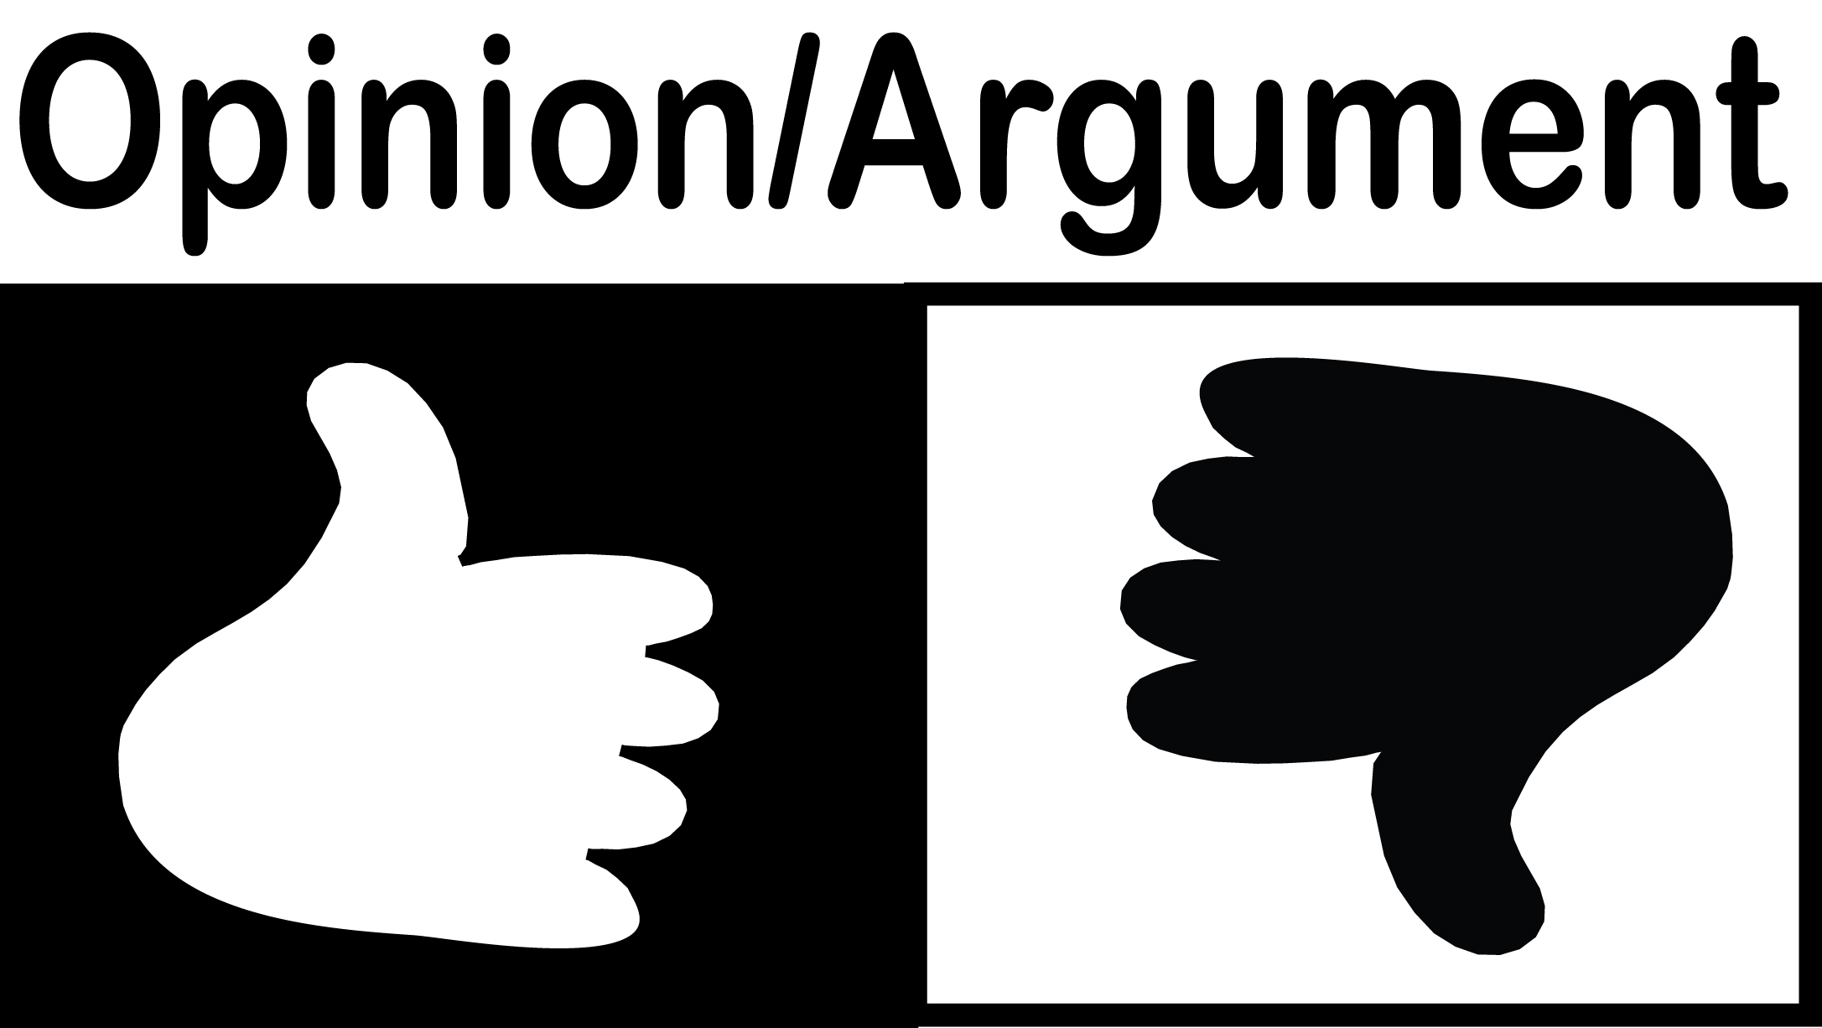

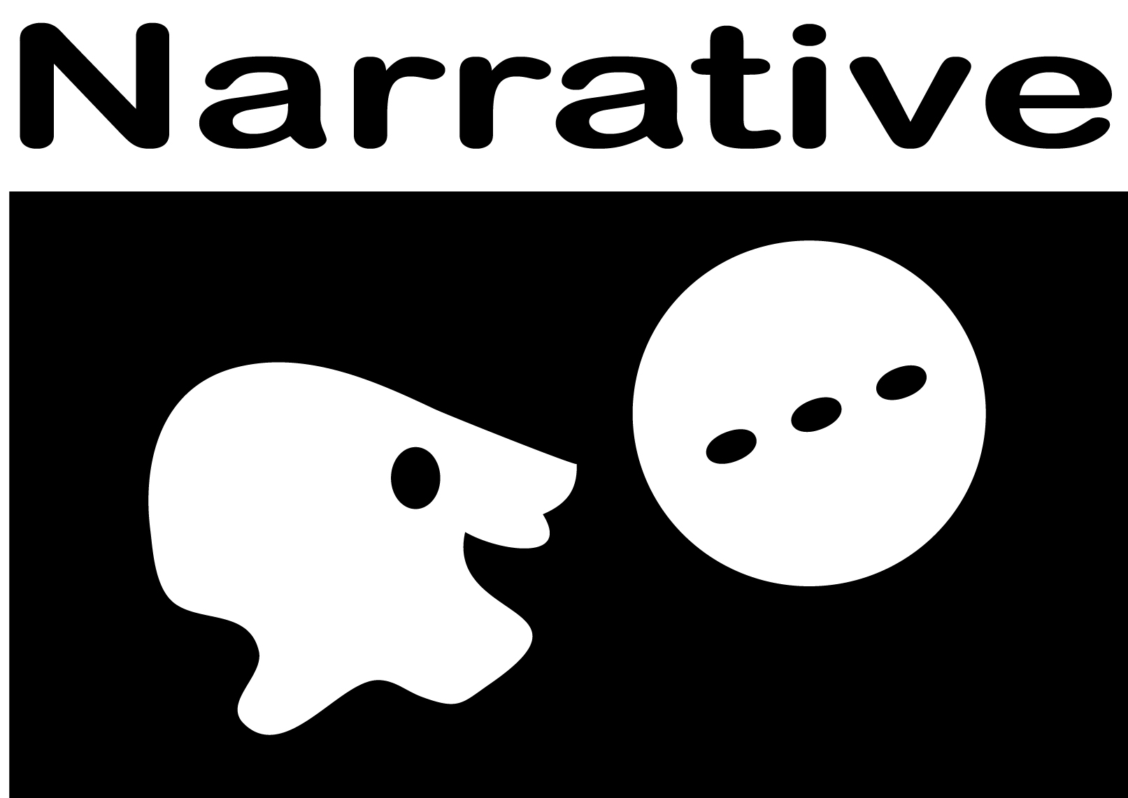
Writing/Language Portfolio Checklist – ALL GENRES - Common Core Standards K-2
- Choose a different color highlighter for each trimester.
- Highlight skills as they are mastered as indicated by writing samples put into portfolio
- Track progress with writing toward grade-level achievement over the course of one or more years.
W | Writing Standards |  |  |  | K-2
Standard 2 |  |  | Grade K | Grade 1 |  |  | Grade 2
Opinion/argument Text |  |  | Use a combination of drawing, dictating, and writing to compose opinion pieces in which they tell a reader the topic or the name of the book they are writing about and state an opinion or preference about the topic or book | … name the topic or book, state an opinion and some reason for opinion, and provide some closure. |  |  | … name the topic or book, state an opinion and reasons to support opinion, use linking words to connect opinion and reasons, and provide some concluding statement or section.
Standard 2 |  |  | Grade K | Grade 1 |  |  | Grade 2
Informative/explanatory Text |  |  | … in which they name what they are writing about and supply some information about the topic. | … name a topic, supply some facts, and provide some closure. |  |  | …introduce a topic, use facts and definitions to develop points, and provide a concluding statement or section.
Standard 3 |  |  | Grade K | Grade 1 |  |  | Grade 2
Narrative Text |  |  | … narrate a single event or several loosely linked events, tell about the events in the order in which they occurred, and provide a reaction to what happened. | … recount two or more appropriately sequenced events, include some details, use temporal words to signal event order, and provide some closure. |  |  | …recount well-elaborated event or short sequence of events; details to describe actions, thoughts and feelings and provide a concluding statement or section.; temporal words; provide sense of closure
Standard 4 |  | Grade K-1 |  | Grade 2
Mostly Organization |  | (Begins in grade 2) CA |  | With guidance and support from adults, produce writing in which the development and organization are appropriate to task and purpose.
Standard 5 |  | Grade K |  | Grade 1 |  |  | Grade 2
Writing Process including Revision and Editing |  | With guidance and support from adults, respond to questions and suggestions from peers and add details to strengthen writing as needed. |  | … focus on a topic, respond to questions and suggestions from peers, and add details to strengthen writing as needed. |  |  | …and peers -focus on a topic and strengthen writing as needed by revising and editing.
Standard 6 |  | Grade K |  | Grade 1 |  |  | Grade 2
Technology |  | With guidance and support from adults, explore a variety of digital tools to produce and publish writing, including collaboration with peers. |  | …use a variety of digital tools to produce and publish writing, including collaboration with peers.
Standard 7 |  |  | Grade K | Grade 1 |  | Grade 2
Research |  |  | Participate in shared research and writing projects. | e.g., explore a number of “how-to” books on a given topic and use them to write a sequence of instructions |  | e.g., read a number of books on a single topic to produce a report; record science observations
Standard 8 |  |  | Grade K | Grade 1 |  | Grade 2
Gather information from multiple sources |  |  | With guidance and support from adults, recall information from experiences or gather information from provided sources to answer a question.
Standard 9 |  |  |  | Grades K-2
Gather evidence to support claims – involved with Text-Dependent Questioning |  |  |  | Begins in grade 4
Standard 10: is writing routinely over longer and shorter term tasks – all grades

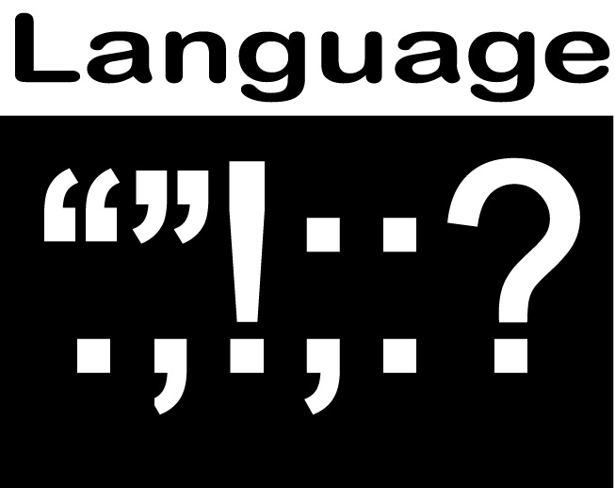  L | LANGUAGE STANDARDS: Conventions of Standard English |  |  | K-2
Standard 1 |  | Grade K | Grade 1 |  | Grade 2
English Conventions when writing or speaking  Nouns/pronouns/ verbs |  | Print many upper- and lowercase letters. | Print all upper- and lowercase letters.
 |  | Use frequently occurring nouns and verbs.  Form regular plural nouns orally by adding /s/ or /es/  Understand and use question words (interrogatives) | Use common, proper, and possessive nouns.  Use singular and plural nouns with matching verbs in basic sentences  Use personal possessive, and indefinite pronouns  Use verbs to convey a sense of past, present, and future |  | Use collective nouns  Form and use frequently occurring irregular plural nouns  Use reflexive pronouns  Form/use past tense of frequently occurring irregular verbs
Other parts of speech |  | Use the most frequently occurring prepositions | Use frequently occurring adjectives.  … occurring conjunctions; determiners (e.g., articles, demonstratives); prepositions |  | Use adjectives and adverbs, and choose between them depending on what is to be modified.
Sentences |  | Produce and expand complete sentences in shared language activities. | …complete simple and compound declarative, interrogative, imperative, and exclamatory sentences in response to prompts. |  | … and rearrange complete simple and compound sentences  Create readable documents with legible print. CA
Capitalization |  | Capitalize the first word in a sentence and the pronoun I. | Capitalize dates and names of people. |  | Capitalize holidays, product names, and geographic names.
Punctuation |  | Recognize and name end punctuation. | Use end punctuation for sentences.  Use commas in dates and to separate single words in a series. |  | Use commas in greetings and closings of letters.  Use an apostrophe to form contractions and frequently occurring possessives.
Spelling |  | Write a letter or letters for most consonant and short-vowel sounds (phonemes).  Spell simple words phonetically, drawing on knowledge of sound-letter relationships. | Use conventional spelling for words with common spelling patterns and for frequently occurring irregular words.  Spell untaught words phonetically, drawing on phonemic awareness and spelling conventions. |  | Generalize learned spelling patterns when writing words  Consult reference materials, including beginning dictionaries, as needed to check and correct spellings
Standard 3 |  | Grade K | Grade 1 |  | Grade 2
Using language and conventions in writing, speaking, reading, or listening |  |  |  |  | Compare formal and informal uses of English.

Writing/Language Portfolio Checklist – ALL GENRES - Common Core Standards 3-5
- Choose a different color highlighter for each trimester.
- Highlight skills as they are mastered as indicated by writing samples put into portfolio
- Track progress with writing toward grade-level achievement over the course of one or more years.
W | Writing Standards |  |  |  |  |  |  | 3-5
Standard 1 |  |  | Grade 3 |  |  | Grade 4 |  |  |  | Grade 5
Opinion/argument Text overview for writing |  |  | Write opinion pieces …supporting a point of view with reasons.  - convey ideas and information clearly.  Introduce the topic or text they are writing about, state opinion, create an organizational structure that lists reasons; provide reasons to support opinion; concluding statement or section. |  |  | …reasons and information; group in paragraphs and sections; introduce clearly, state opinion; organizational structure with ideas grouped to support writer’s purpose; support reasons with facts and details; link opinion and reasons using words and phrases; provide a concluding statement or section related to opinion. |  |  |  | …(same-plus) . logically ordered reasons supported by facts and details; link opinion and reasons with words, phrases, and clauses; concluding statement etc.
Standard 2 |  |  | Grade 3 |  |  | Grade 4 |  |  |  | Grade 5
Informative/explanatory Text overview for writing |  |  | - convey ideas and information clearly.  - group related information; include illustrations when useful.  Develop the topic with facts, definitions, and details. Use linking words and phrases; Provide a concluding statement or section. |  |  | …group in paragraphs and sections; include formatting illustrations, and multimedia. Develop - facts, definitions, concrete details, quotations. Link ideas; use precise language and domain-specific vocabulary; provide a concluding statement or section |  |  |  | Introduce clearly, general observation and focus, group information logically; link ideas within and across categories information using words, phrases, and clauses; precise language and domain-specific vocabulary; concluding statement…
Standard 3 |  |  | Grade 3 |  |  | Grade 4 |  |  |  | Grade 5
Narrative Text overview for writing |  |  | … real/imagined experiences/events - effective technique, descriptive details, and clear event sequences. Establish situation; intro narrator/characters; organize event sequence that unfolds naturally. Use dialogue, descriptions of actions, thoughts, and feelings to develop events or response of characters. Use temporal words/phrases to signal order; provide a sense of closure. |  |  | …(all-plus) use temporal words…to covey experiences and events precisely; provide a conclusion that that follows from narrated experiences and events. |  |  |  | …(same-plus)…use dialogue, description, and pacing; use variety of transitional words, phrases, and clauses to develop experiences/events or show responses of characters to situations; conclusion….
Standard 4 |  | Grade 3 |  |  | Grade 4 |  |  |  | Grade 5
Mostly Organization |  | With guidance and support from adults, produce writing in which the development and organization are appropriate to task and purpose. |  |  | Produce clear and coherent writing (including multiple-paragraph texts) in which the development and organization are appropriate to task, purpose, and audience.
Standard 5 |  | Grade 3 |  |  | Grade 4 |  |  |  | Grade 5
Writing Process including Revision and Editing |  | With guidance and support from peers and adults, develop and strengthen writing as needed by planning, revising, and editing. (Editing for conventions should demonstrate command of Language standards to grade level.) |  |  |  |  |  |  | …or trying a new approach. (Editing for conventions should demonstrate command of Language standards to grade 5.
Standard 6 |  | Grade 3 |  |  |  | Grade 4 |  |  |  |  | Grade 5
Technology |  | With guidance and support from adults, use technology to produce and publish writing (using keyboarding skills) as well as to interact and collaborate with others |  |  |  | including the Internet, …demonstrate sufficient command of keyboarding skills to type a minimum of one page in a single sitting. |  |  |  |  | … type a minimum of two pages in a single sitting.
Standard 7 |  |  | Grade 3 |  | Grade 4 |  |  |  | Grade 5
Research |  |  | Conduct short research projects that build knowledge about a topic |  | … through investigation of different aspects of a topic. |  |  |  | … that use several sources to build knowledge through investigation of different aspects of a topic.
Standard 8 |  |  | Grade 3 |  | Grade 4 |  |  |  | Grade 5
Gather information from multiple sources |  |  | …take brief notes on sources and sort evidence into provided categories. |  | … use print and digital sources; take notes, paraphrase, categorize; provide a list of sources. |  |  |  | …summarize or paraphrase information in notes and finished work, and provide a list of sources.
Standard 9 |  |  | Grades 3 | Grade 4 |  |  | Grade 5
Gather evidence from literary or informational texts (apply reading standards) to support claims – use Text-Dependent Questioning |  |  | Begins in grade 4 | …literature (describe in depth a character, setting, event in story/drama, drawing on specific details in the text (character’s thoughts, words, actions).  …informational texts (e.g., “Explain how an author uses reasons and evidence to support particular points in a text”). |  |  | … literature (e.g., “Compare and contrast two or more characters, settings, or events in a story or a drama, drawing on specific details in the text  … informational texts (e.g., “Explain how an author uses reasons and evidence to support particular points in a text, identifying which reasons and evidence support which point[s]”).
Standard 10: is writing routinely over longer and shorter term tasks (time for research, reflection, and revision) and shorter time frames (a single sitting or a day or two) for a range of discipline-specific tasks, purposes, and audiences. – all grades

L | LANGUAGE STANDARDS: Conventions of Standard English |  |  | 3-5
Standard 1 |  | Grade 3 | Grade 4 |  |  | Grade 5
English Conventions when writing or speaking  Nouns/pronouns/verbs |  | Explain function of nouns, pronouns, verbs, adjectives, adverbs in general and functions in particular sentences. Use regular/irregular plural nouns; abstract nouns; irregular verbs; simple verb tenses; subject-verb and pronoun-antecedent agreement; use comparative and superlative adjectives and adverbs | Use interrogative, relative pronouns, relative adverbs;  progressive verb tenses; modal auxiliaries; prepositional phrases; order adjectives w’in sentences; use complete sentences, correcting fragments/run-ons; correctly use frequently confused words; write fluidly and legibly in cursive or joined italics |  |  | Explain function of conjunctions, prepositions, and interjections.  Use the perfect verb tenses. Use verb tense to convey various times, sequences, states, and conditions.  Correct inappropriate shifts in verb tense.
Other parts of speech |  | Use coordinating and subordinating conjunctions | Use frequently occurring adjectives. |  |  | Use correlative conjunctions
Sentences |  | -simple, compound, complex sentences; legible cursive or joined italics, with margins and spacing; use reciprocal pronouns correctly | …complete simple and compound declarative, interrogative, imperative, and exclamatory sentences in response to prompts.
Capitalization |  | Capitalize appropriate words in titles | Use correct capitalization
Punctuation |  | Use commas in addresses; with quotation marks in dialogue.  Use possessives. | Use commas and quotation marks to mark direct speech and quotations from a text; - comma before a coordinating conjunction in a compound sentence. |  | Use comma to separate an introductory element; to set off the words yes and no, to set off a tag question, and direct address.  Use underlining, quotation marks, or for titles of works.
Spelling |  | Use spelling patterns: word families, position-based spellings, syllable patterns, ending rules, meaningful word parts. Consult reference mat. to check spelling. | Spell grade-appropriate words correctly, consulting references as needed.
Standard 3 |  | Grade 3 | Grade 4 |  | Grade 5
Using language and conventions in writing, speaking, reading, or listening |  | Choose words and phrases for effect.  Recognize and observe differences between the conventions of spoken and written standard English. | Choose words and phrases to convey ideas precisely.  Choose punctuation for effect.  Differentiate - contexts formal/informal English |  | Expand, combine, and reduce sentences for meaning, reader/listener interest, and style.  Compare/contrast English used in stories, dramas, or poems

